This week Alex (P6) has used World War 2 as his WW2 theme to help him with his studies.

Alex covered Maths by kitting out his platoon with supplies, and followed the Liverpool War Museum’s resources online. That involved Alex watching a 30 minute film each day, followed by some worksheets to check his understanding. The themes were Western Command HQ in the Secret Bunker during the Battle of the Atlantic, Food and Rationing, Evacuation, and Coding.

Each day Alex did a project based on the themes he had followed.

Below is a lego model of the Western Command HQ (accurate representation of the symbols and pins used by the mappers to track the movement in the Battle of the Atlantic). Also had a ‘working’ telegraph machine!

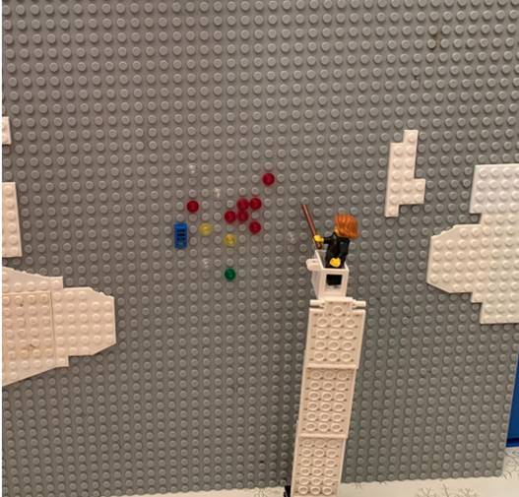

After studying Morse code, Alex displayed the code for the word ‘lego’
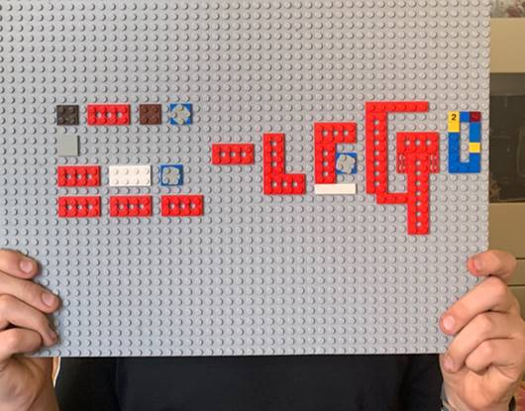

In Food and Rationing – he made himself torn bread soaked in milk (a common wartime meal), planned meals for a week based on ration allowances, and then made us an amazing corned beef hotpot for tea!
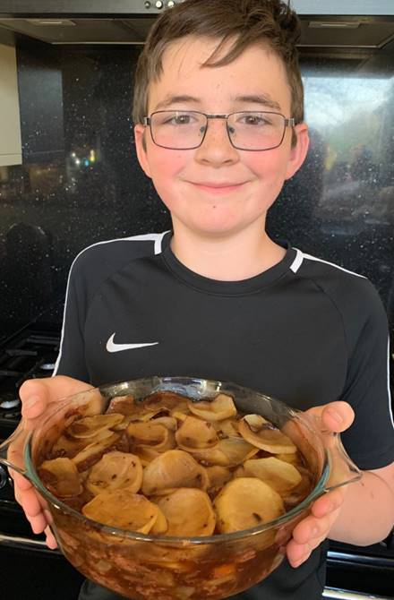

We would all have liked a big scoop of that hotpot Alex – Fabulous work, Well done!

