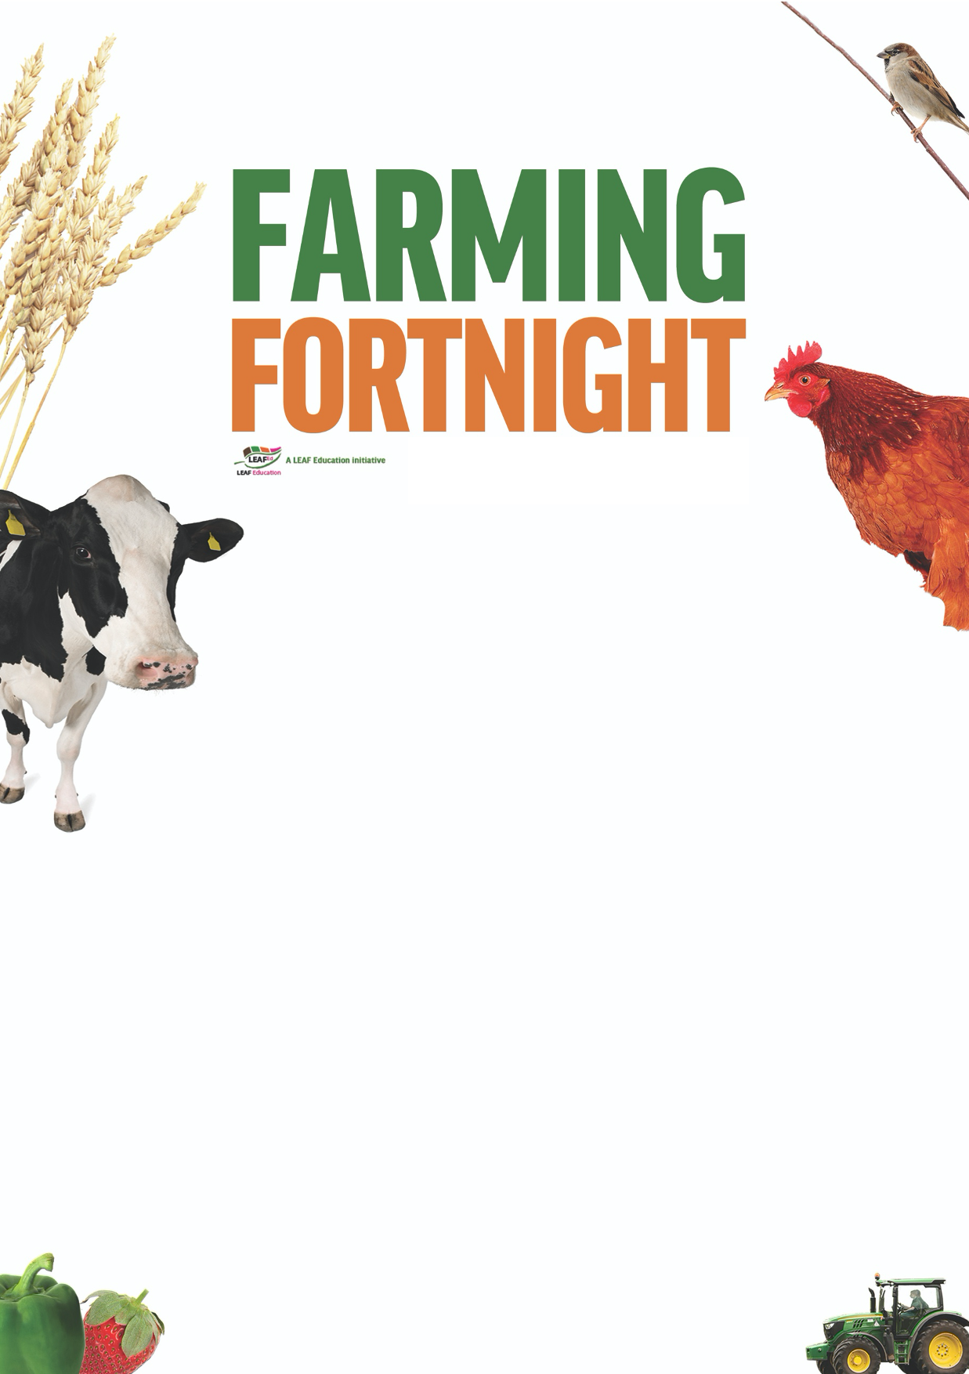

**Teacher’s notes**

**What is farming?**

**#MarketMonday**

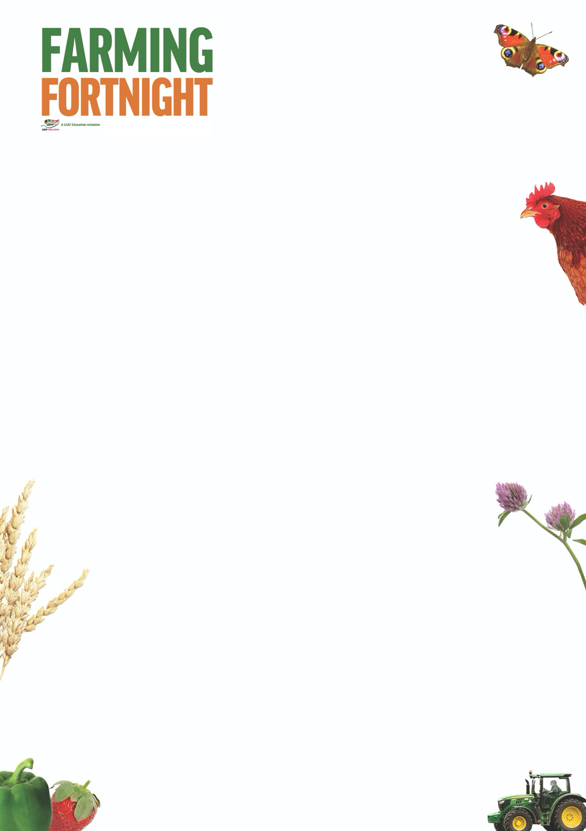

**What is farming?**

The aim of this session is to:

* Encourage students to consider what farming means to them and how farming benefits their lives, by providing food and raw materials;
* Enable students to identify the different types of farming activity that exist within the UK, and the different foods that come from each type of farm:
  + Arable
  + Dairy
  + Beef
  + Poultry
  + Fruit and vegetables
  + Sheep
  + Pigs
* Encourage students to understand the different activities that are taking place on farms across the country every day, both to produce food but also to care for the environment;
* Encourage students to think about the journey that their food has taken as it travels from field to fork;
* Increase awareness of the changes taking place within agriculture as technological advances revolutionise farming practices.

By the end of this session, students will:

* Have a good understanding of the importance of UK agriculture and its role in managing the countryside.

The ‘What is Farming?’ PowerPoint is designed to be used within a classroom or interactive assembly environment. Students are asked to consider their understanding of the farm environment and its role within the UK and then to develop their awareness of the different foods grown and reared on a farm and how that relates to the food that they eat and the countryside as a whole.

For further information on using farming and the countryside within education, visit:

<https://leafuk.org/education/leaf-education>

[www.countrysideclassroom.org.uk](http://www.countrysideclassroom.org.uk/)

[www.whyfarmingmatters.co.uk](http://www.whyfarmingmatters.co.uk/)

<https://leafuk.org/farmertime/home>



**What is farming? KS2**

The ‘What is farming?’ Powerpoint is in itself a stand-alone resource; however the pupils may also benefit from the resources available to download at [www.whyfarmingmatters.co.uk](http://www.whyfarmingmatters.co.uk) particularly [www.whyfarmingmatters.co.uk/using-the-picture-cards](http://www.whyfarmingmatters.co.uk/using-the-picture-cards).

What is a farm?

A farm is land that is used for growing plants or raising animals for food or to be used to make something else. Can you pretend to be the animals that we might find on the farm? What would they sound like? How would they move? What would they eat?

For the Q&A, the picture cards and video available on the why farming matters website will benefit those students with little experience of exploring the British countryside to consider habitats such as fields, woodland, hedgerows and streams when asked who might live on the farm and what might we find there.

Inspire your pupils to discover the world of nature using the beautifully illustrated book ‘The Lost Words’ by Robert MacFarlane, and the associated challenge cards available to download from <https://www.countrysideclassroom.org.uk/resources/1299>

* What does a farmer look like?

Pupils are encouraged to consider that not all farmers wear wellies and that farming takes place all over the world indoors and outdoors. The photos encourage the pupils to consider how modern technology is changing the role of the farmer and therefore what a farmer typically looks like!

What jobs on the farm could a robot farmer help with?

* What did you have for breakfast today?
  + Milk, yoghurt, cheese – dairy farm
  + Breakfast cereal, toast, bagel – arable farm
  + Bacon, ham, sausages – pig farm
  + Egg (poached, boiled, fried), omelette – poultry farm

What do your friends like to eat? What would you have on your farm if you had to feed your friends?

* Finish these sentences:

A farmer works hard to produce food so that we (humans and animals) can all eat

A farmer works hard to grow crops so that we (humans and animals) can all eat

A farmer raises animals so that we (humans and animals) can all eat

A farmer looks after the countryside so that we all have a future.

Can you make a model of your perfect farm? What crops would you grow? What materials would you use to build the animals’ homes? What technology would you use?

On page 19 of the downloadable booklet there is a useful prompt for KS3/4 students when asked to consider ingredients of their favourite dinner and identify where those ingredients have come from, and the industries involved in producing, transporting and processing those components.

KS1/2 The session works well in conjunction with seasonality, life cycles, food webs, local community, land usage,

KS3/4 The session works well as students explore the wider world and the roles that different economic sectors play within the economy and consider the impact that their decisions (ie food choices) have on the economy and the wider environment. It is also an effective study of the effect of evolving ICT development and the impacts upon society as a whole.