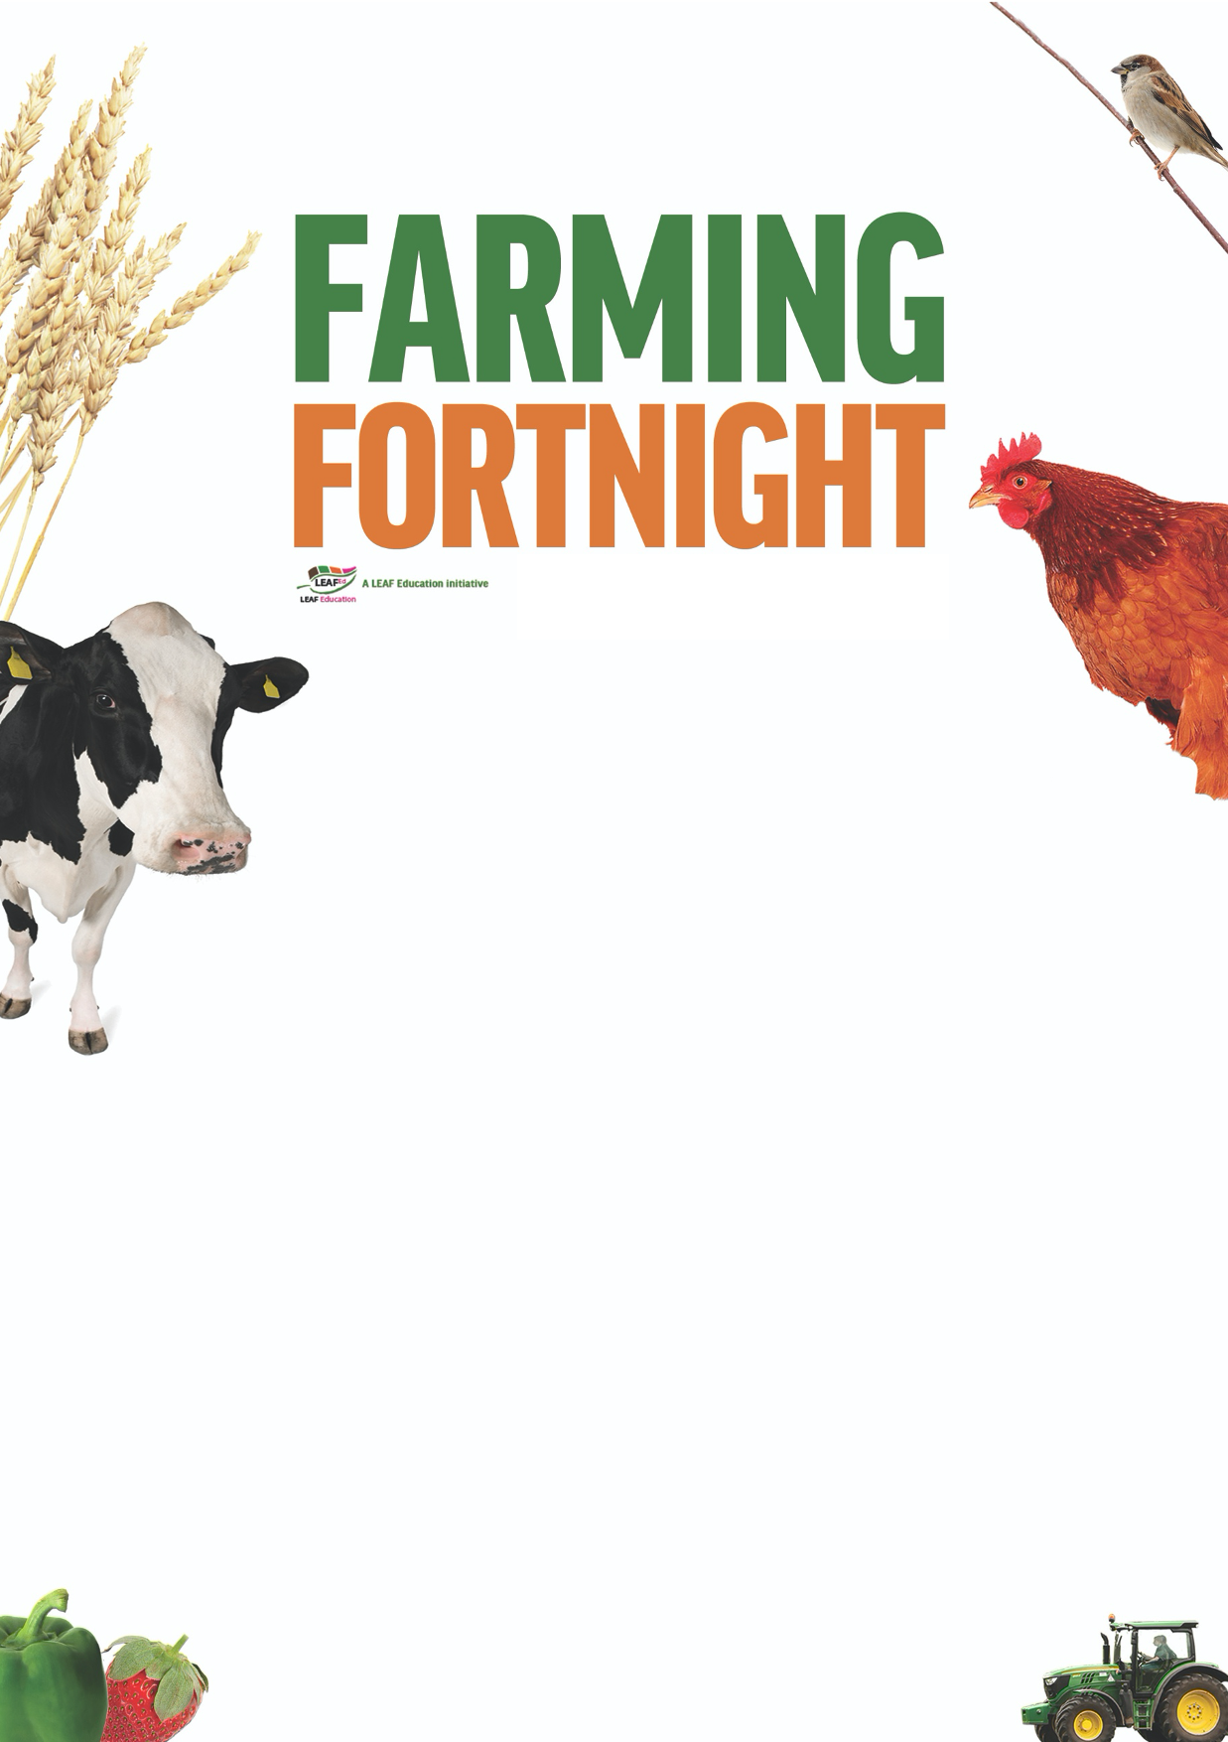

**Teacher’s notes**

**What is farming?**

**#MarketMonday**

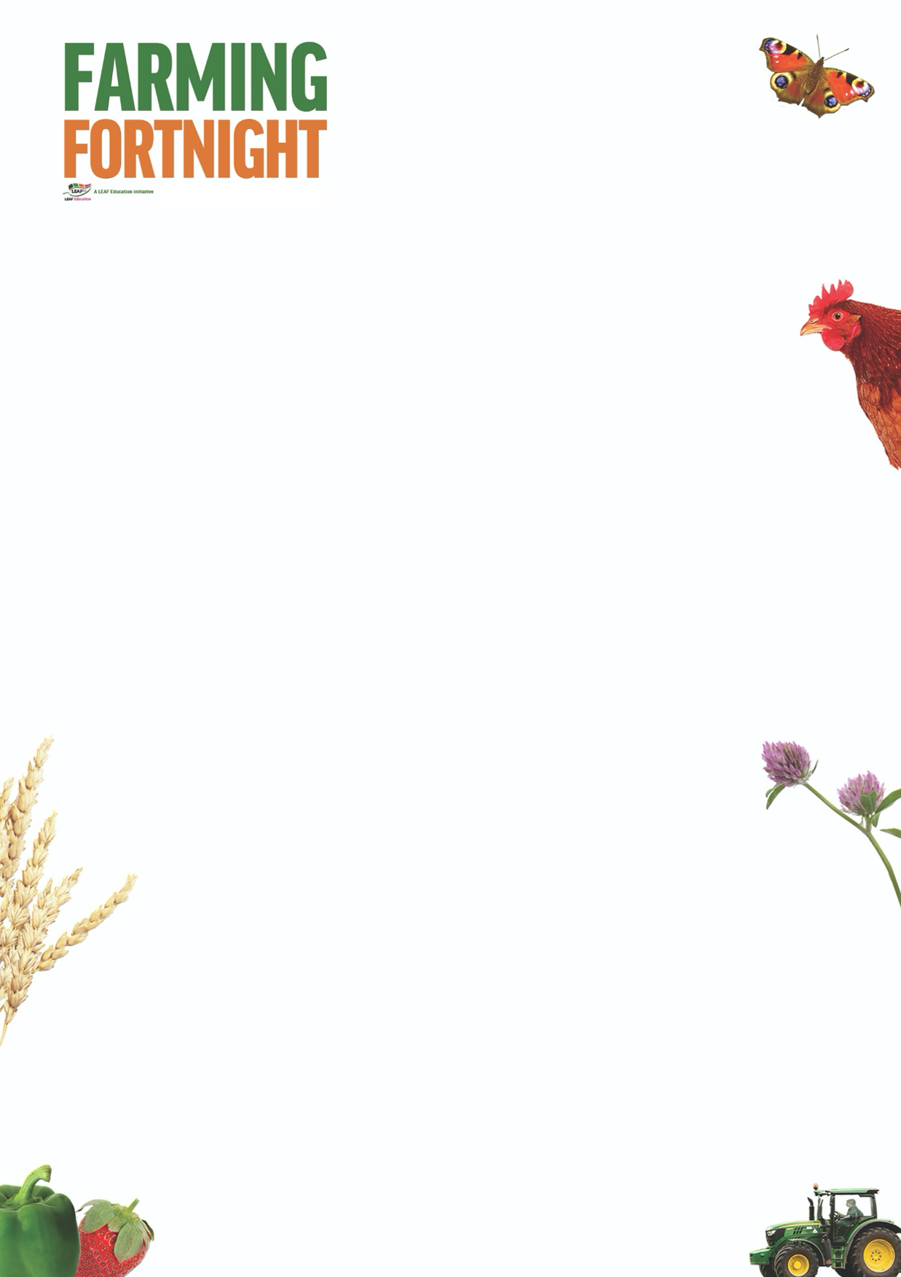

**What is farming?**

The aim of this session is to:

* Encourage students to consider what farming means to them and how farming benefits their lives, by providing food and raw materials;
* Enable students to identify the different types of farming activity that exist within the UK, and the different foods that come from each type of farm:
  + Arable
  + Dairy
  + Beef
  + Poultry
  + Fruit and vegetables
  + Sheep
  + Pigs
* Encourage students to understand the different activities that are taking place on farms across the country every day, both to produce food but also to care for the environment;
* Encourage students to think about the journey that their food has taken as it travels from field to fork;
* Increase awareness of the changes taking place within agriculture as technological advances revolutionise farming practices.

By the end of this session, students will:

* Have a good understanding of the importance of UK agriculture and its role in managing the countryside.

The ‘What is Farming?’ PowerPoint is designed to be used within a classroom or interactive assembly environment. Students are asked to consider their understanding of the farm environment and its role within the UK and then to develop their awareness of the different foods grown and reared on a farm and how that relates to the food that they eat and the countryside as a whole.

For further information on using farming and the countryside within education, visit:

<https://leafuk.org/education/leaf-education>

[www.countrysideclassroom.org.uk](http://www.countrysideclassroom.org.uk/)

[www.whyfarmingmatters.co.uk](http://www.whyfarmingmatters.co.uk/)

<https://leafuk.org/farmertime/home>



**What is farming? KS3/4**

The ‘What is farming?’ PowerPoint is in itself a stand-alone resource, however the pupils may also benefit from the resources available to download at [www.whyfarmingmatters.co.uk](http://www.whyfarmingmatters.co.uk) particularly [www.whyfarmingmatters.co.uk/using-the-picture-cards](http://www.whyfarmingmatters.co.uk/using-the-picture-cards).

What is a farm?

A farm is land that is used for growing crops (plants or animals) for food or to be used to make something else. Look around, what can you see that was might have been made using products from a farm?

For the Q&A, the picture cards and video available on the why farming matters website will benefit those students with little experience of exploring the British countryside to consider habitats such as fields, woodland, hedgerows and streams when asked who might live on the farm and what might we find there.

Inspire your pupils to consider the world of nature using the beautifully illustrated book ‘The Lost Words’ by Robert MacFarlane, and the associated challenge cards available to download from <https://www.countrysideclassroom.org.uk/resources/1299>

* What does a farmer look like?

How has modern technology changed the role of the farmer and therefore what a farmer typically looks like? How has farming evolved over the last 100 years, and how will it evolve over the next 100 years (consider aquaculture, underground farming, vertical farming, air and soil sensors, precision technology, drones, genetically modified plants, health sensors, robotic technology)?

* What did you have for breakfast today?
  + Milk, yoghurt, cheese – dairy farm
  + Breakfast cereal, toast, bagel – arable farm
  + Bacon, ham, sausages – pig farm
  + Egg (poached, boiled, fried), omelette – poultry farm

Students to list the ingredients of their favourite dinner and identify where those ingredients have come from, and the industries involved in producing, transporting and processing those components. An example can be found on page 21 of the Why farming matters booklet downloadable from [www.whyfarmingmatters.co.uk](http://www.whyfarmingmatters.co.uk)

* Finish these sentences:

A farmer works hard to produce food so that we (humans and animals) can all eat

A farmer works hard to grow crops so that we (humans and animals) can all eat

A farmer raises animals so that we (humans and animals) can all eat

A farmer looks after the countryside so that we all have a future.

If we didn’t have farmers where would our food come from and who would care for the countryside? ……….

On page 19 of the downloadable booklet there is a useful prompt for KS3/4 students when asked to consider ingredients of their favourite dinner and identify where those ingredients have come from, and the industries involved in producing, transporting and processing those components.

KS1/2 The session works well in conjunction with seasonality, life cycles, food webs, local community, land usage,

KS3/4 The session works well as students explore the wider world and the roles that different economic sectors play within the economy and consider the impact that their decisions (ie food choices) have on the economy and the wider environment. It is also an effective study of the effect of evolving ICT development and the impacts upon society as a whole.