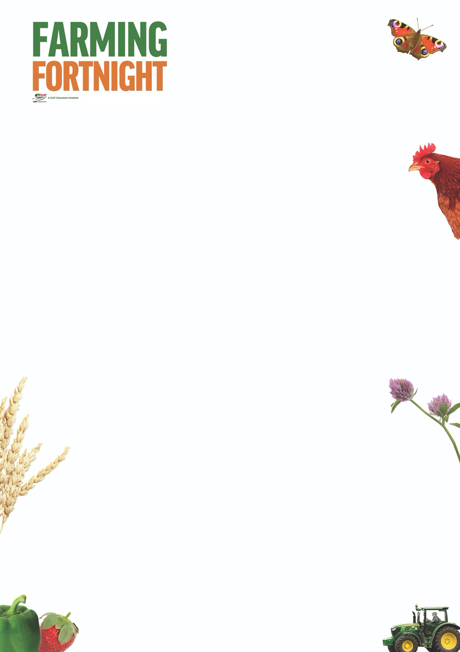

**Arable: Primary**

This session has a range of activities that introduce pupils to arable farming in the UK. Pupils can try and name the main crops grown in this country and then match these crops to familiar products. Pupils can then focus on wheat; how it is grown and how it is used in the production of bread. As a follow on activity, pupils may like to taste test different breads and consider that these breads originate from different countries around the world.

**Introduction**

* Ask the pupils what are the 3 main types of farming in the UK
* Livestock (animals)
* Arable (crops)
* Mixed (both of the above)
* The picture cards on the Arable Primary PowerPoint can be used as prompts if required.
* Can the pupils come up with a list of the main crops grown in the UK? Again the picture cards on the Arable Primary PowerPoint can be used. How many can they identify?
* Oats, wheat, barley, oil seed rape, potatoes, sugar beet, vegetables, fruit

**Activity Ideas**

* Can the pupils **match a crop to a product**? This could be done as a class or in groups. Which team can get the most right? Picture cards are available on the Arable Primary PowerPoint.
* Oats; porridge, wheat; bread, barley; malt vinegar, oil seed rape; oil, potatoes; crisps, sugar beet; sugar, vegetables; vegetable soup, fruit; apple pie
* **How do we make bread from wheat?** Use a pepper grinder, pestle and mortar or small grain mill to grind some wheat seeds (seeds are available to buy online). The inner part of the wheat contains the flour.
* **Taste Test some different breads**
* Why not taste some different breads? (white bread, wholegrain bread, pitta bread, naan bread, baguette, focaccia)
* Which is your favourite bread? Why is it your favourite?
* Which bread is the most popular?
* Introduce the idea that different breads come from different countries
* **Try growing some wheat seedlings**
* Soak some wheat seedlings for 8 hours in water. Once soaked, transfer the seedlings in to a clean jam jar with a lid. Don’t add any water. Every 24 hrs tip the seedlings out and rinse in a sieve with water. Put the seedlings back in the jar. Place the jar in a light place but out of direct sunlight. Rinse the seedlings each day for about 3 – 4 days. Once the seedlings are sprouting well they can be transferred to pots with compost in them. Wheat seedlings can be bought on line from health food shops.

**Further Links**

**LEAF Education** <https://education.leafuk.org/>

**Farmer Time** <https://leafuk.org/farmertime/home>