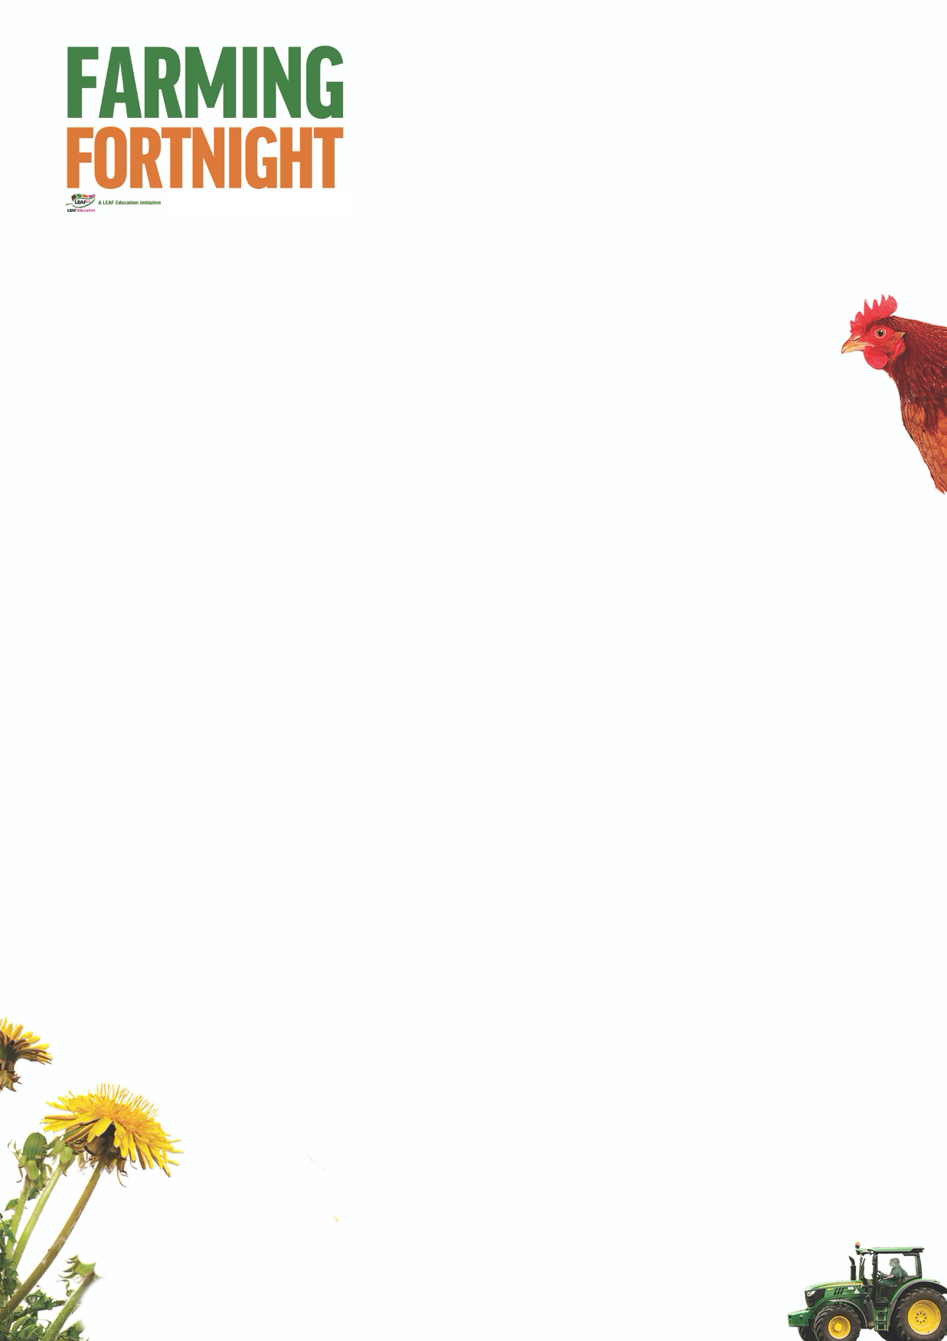

**Arable: Secondary**

This session starts with an activity that introduces the different types of farming in the UK and the different crops grown on UK arable farms. Pupils can then match familiar products to crops as well as consider how many loaves of bread can be produced on a 1 metre square of land. As a follow on activity, pupils can look at the challenges facing wheat production in the future and try and design the “Wheat of the Future”.

**Introduction**

* Ask the pupils what are the 3 main types of farming in the UK
* Livestock (animals), Arable (crops), Mixed (both of the above)
* The picture cards on the Arable Secondary PowerPoint can be used as prompts if required.
* Can the pupils come up with a list of the main crops grown in the UK? Again the picture cards on the Arable Primary PowerPoint can be used. How many can they identify?
* Oats, wheat, barley, oil seed rape, potatoes, sugar beet, vegetables, fruit

**Activity Ideas**

* Can the pupils **match a crop to a product**? This could be done as a class or in groups. Which team can get the most right? Picture cards are available on the Arable Primary PowerPoint.
* Oats; porridge, wheat; bread, barley; malt vinegar, oil seed rape; oil, potatoes; crisps, sugar beet; sugar, vegetables; vegetable soup, fruit; apple pie
* **Marvellous Mini Fields**
* How many loaves of bread can a farmer grow from a 1 metre square of wheat crop? Can pupils guess? Make a tally on the board.
* Using 1m rulers mark out a 1m square
* Pupils / volunteers to count out 250 wheat seeds and put in a container or pre count out and ask pupils to guess how many (possibly a prize to the nearest guess?) (Wheat seeds can be bought from online health food shops)
* Show an ear of wheat / or a picture from the PowerPoint resource – how many seeds from one ear of wheat? 40 – 60 seeds
* 1m square will yield 1 kilo of wheat seeds which will give 800g of flour (have the amount of flour weighed out)
* If available, use a hand pepper mill to grind some wheat seeds
* 800g of flour should produce **2 average size loaves of bread – who guessed correctly?**
* **Adapted from the Let Nature feed Your Senses “Marvellous Mini Fields” activity**
* **Future Wheat – Do we need to design the Wheat of the Future?**

Global population is predicted to increase to 9 billion by 2050. To meet demand, it is thought that globally wheat production needs to increase by 60%. <https://www.countrysideclassroom.org.uk/resources/1240> Future Wheat Poster

* How can we produce more wheat with the same amount of land and water that we have today? (increase yields / quicker growing)
* Are there any other threats to our supply of wheat? (plant disease, flooding, drought, pests)
* If you were a plant scientist who specialised in breeding new plant varieties, what characteristics would you want to breed into your new wheat variety? (more nutritious, disease / pest resistant, drought / flood resistant)

**Further Links**

**LEAF Education** <https://education.leafuk.org/>

**Farmer Time** <https://leafuk.org/farmertime/home>