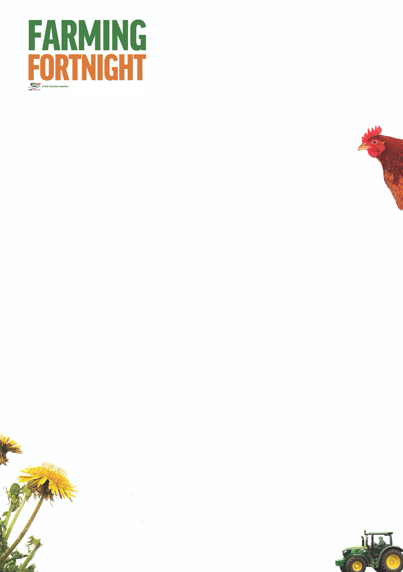

**Arable: EYFS**

This session allows younger pupils to think about farms and consider the fact that some farms look after animals and some grow plants for food. Pupils can then be introduced to the 3 main arable crops grown in the UK and match them to a familiar product. Following this, pupils can look more closely at wheat and how it is used to make bread. As a follow on activity, you may like to taste test some different breads and introduce the idea that the different breads come from different countries. If growing is something your pupils enjoy, they may like to plant some wheat seedlings.

**Introduction**

* Some farmers look after animals on their farm but other farmers grow plants.
* Do the pupils know why the farmer grows plants? Discuss with the children that plants give us food.

**Activity Ideas**

* Can the pupils **match a crop to a product**?
* Use the picture cards on the Arable EYFS PowerPoint
  + Wheat / bread
  + Potatoes / crisps
  + Oats / porridge
* **Sequencing activity**. Use the “Cereals – the journey” cards to sequence wheat growing to making bread

<https://www.foodafactoflife.org.uk/3-5-years/food-commodities/>

* **Taste Test some different breads**
* Why not taste some different breads? (white bread, wholegrain bread, pitta bread, naan bread, baguette, focaccia)
* Which is your favourite bread; why is it your favourite?
* Which bread is the most popular?
* Introduce the idea that different breads come from different countries
* **Try growing some wheat seedlings**
* Soak some wheat seedlings for 8 hours in water. Once soaked, transfer the seedlings in to a clean jam jar with a lid. Don’t add any water. Every 24 hrs tip the seedlings out and rinse in a sieve with water. Put the seedlings back in the jar. Place the jar in a light place but out of direct sunlight. Rinse the seedlings each day for about 3 – 4 days. Once the seedlings are sprouting well they can be transferred to pots with compost in them. Wheat seedlings can be bought on line from health food shops.

**Further Links**

**LEAF Education** <https://education.leafuk.org/>

**Farmer Time** <https://leafuk.org/farmertime/home>