My

Wellbeing

This journal belongs to:

Journal

Make up an exercise or dance routine

to your favourite song and teach it to

friends by making a video. Challenge Mum

and Dad to join in… can they keep up!?

Create a reading list and set aside 30

minutes before bedtime to replace screens

and phones with a book. How many books

can you read this week?

Think about three good things that made

you happy today.

Make sure you eat vitamin-packed fruit and

veg to boost your immune system and stay

healthy – aim for a variety of colours each

day. On the plate, draw your food rainbow.

How I move

How I sleep

How I feel

How I eat

**Which song did you choose**

**and what was your favourite**

**exercise or move you**

**included?**

**List the books you read below**

**and write a summary or draw a**

**picture of your favourite story.**

HOW I MOVE

HOW I SLEEP

**Did you eat a full rainbow of colours**

**today? Did you miss any colours out and**

**can you include these tomorrow?**

HOW I EAT



HOW I FEEL

**Write your three good things below:**

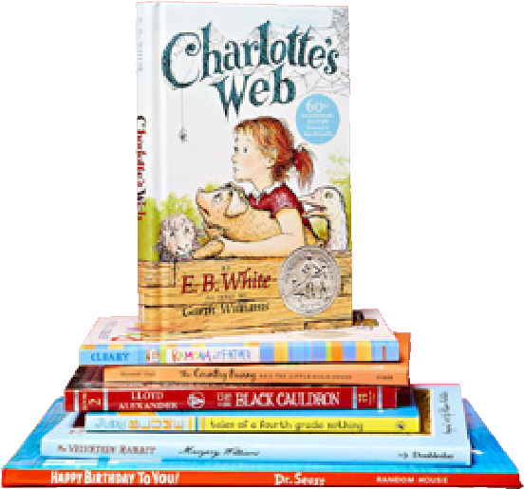

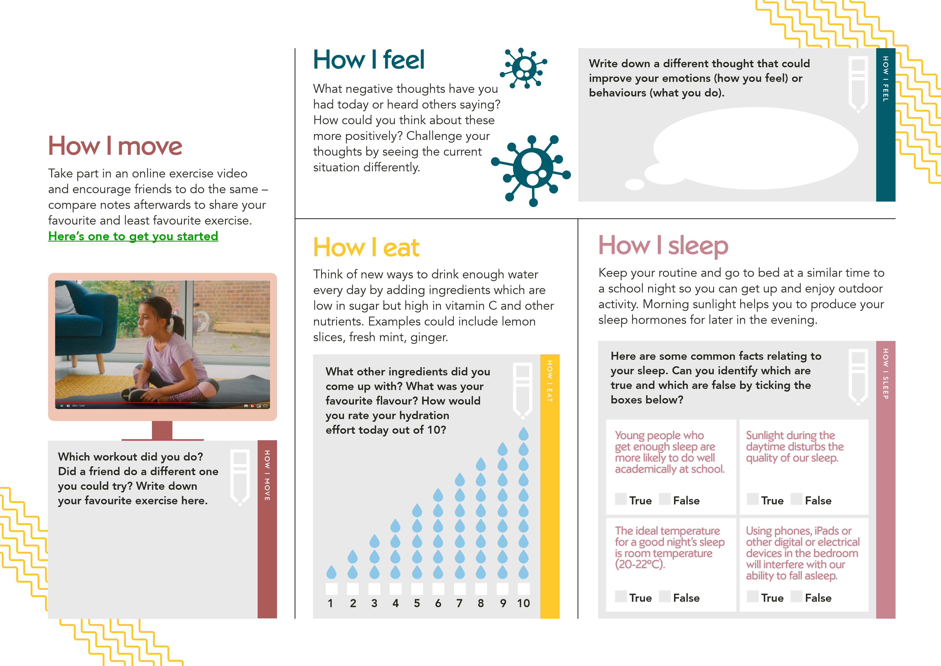

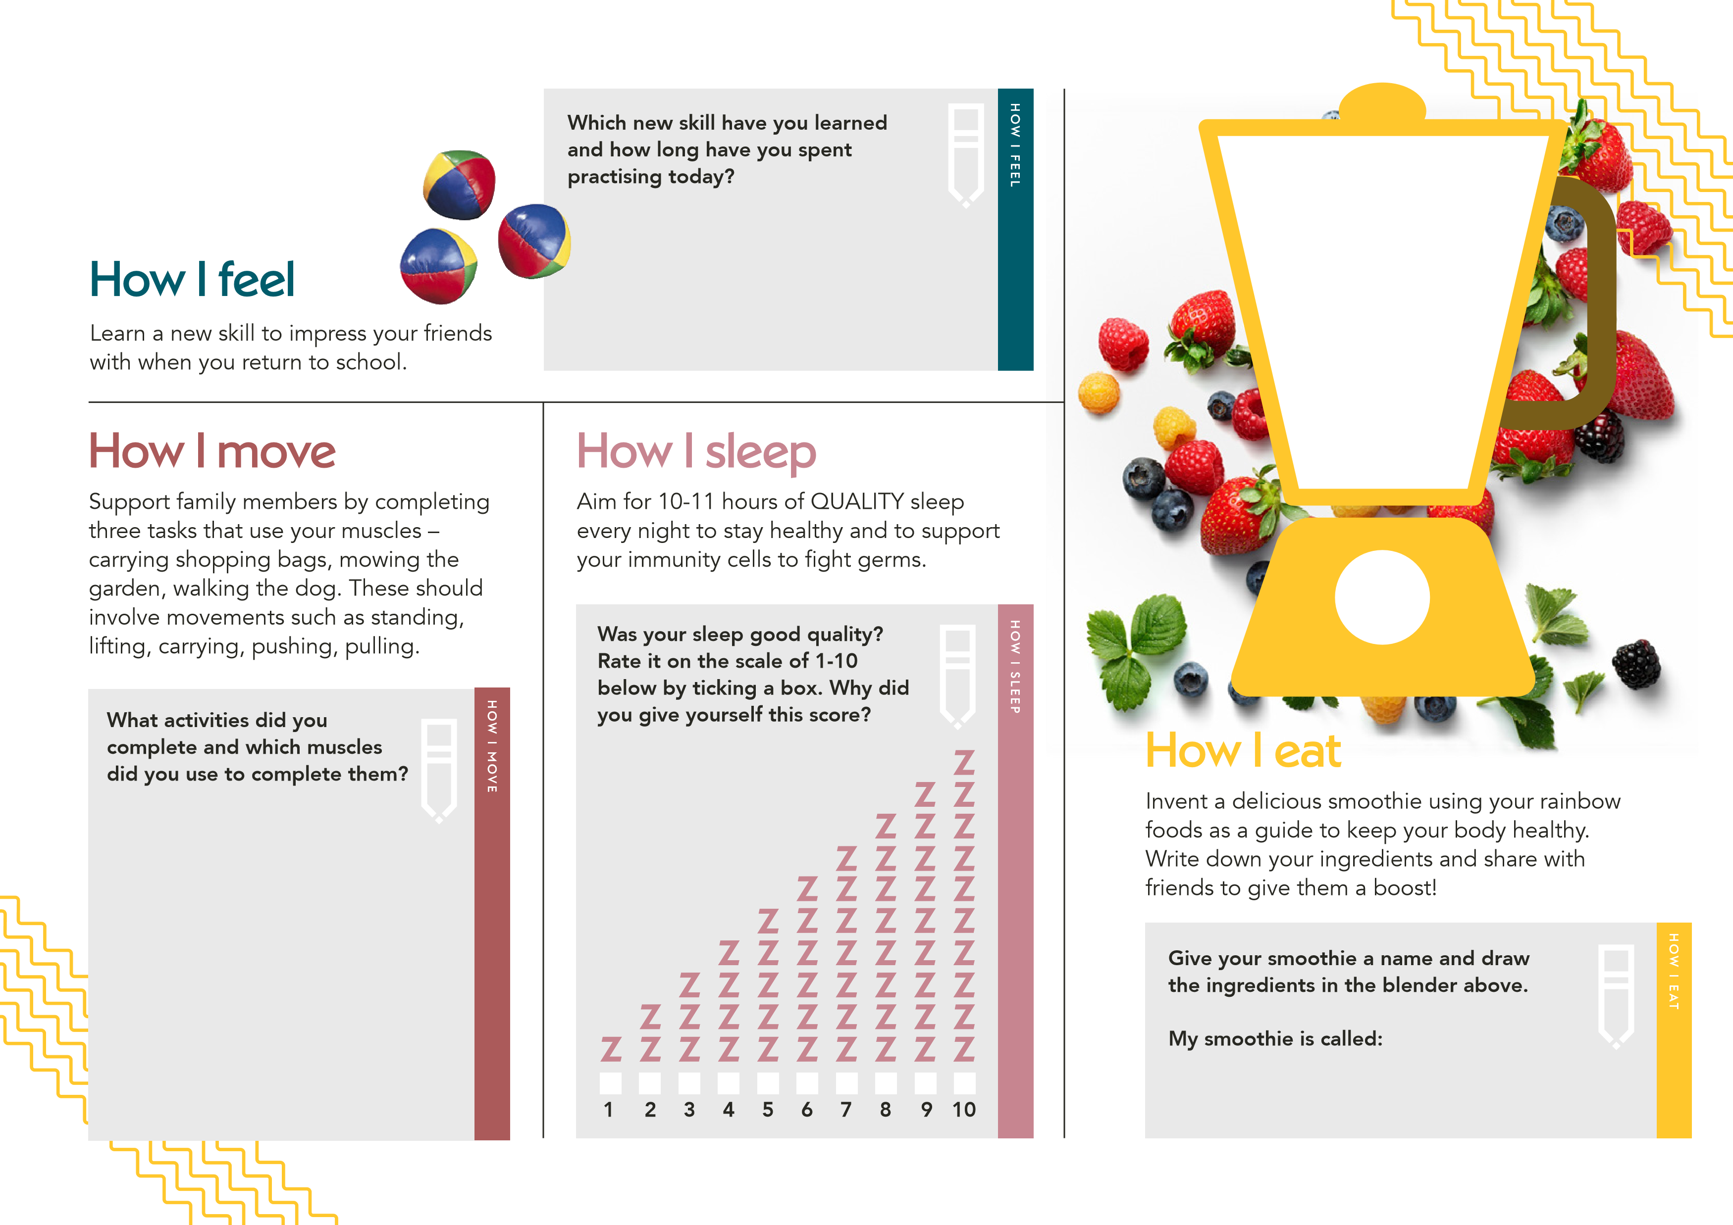



Try three new ways to help

you relax and recommend

them to others. This could be

meditation, mindfulness, yoga,

progressive muscular relaxation

tense a muscle and hold for

(

five seconds, work through the

body from head to toe), tai chi

or deep breathing for example.

Find an app to learn a relaxation

exercise but remember not to

use your phone in bed!

How I sleep

**Which new relaxation activities did you**

**try and how did they make you feel?**

**Which one worked best for you?**

HOW I SLEEP

Complete at least one hour of physical

activity each day that makes you

breathless to keep your heart and lungs

healthy. Do you have a garden to play

games in? E.g. football, skipping, stuck in

the mud with parents or siblings.

Perform a random act of

kindness today such as

cleaning a room in your

house without being asked,

making something or

writing a card for a

member of your family.

How I move

How I feel

**Here are some exercise facts.**

**Can you identify which are true**

**and which are false by ticking**

**the boxes below?**

HOW I MOVE

How I eat

**Which super food did you eat**

**today and what vitamin or mineral**

**does it contain? Research what**

**benefit this nutrient has for your**

**body and record your findings below:**

HOW I EAT

Learn about a anti-oxidant rich ‘super food’

you can include in your diet that contains a

vitamin or mineral to protect your cells and

body against damage and keep you healthy.

**What act of kindness did you do? Write below**

**how it made you feel?**

HOW I FEEL

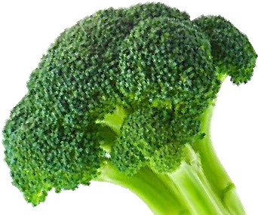

**My**

**favourite**

**app to relax**

**to is:**

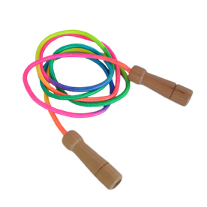

Ballet improves

football skills.

Exercising

outside has no

more benefits

than exercising

inside.

Hopping makes

your bones

stronger.

Regular

exercise cuts

your risk of

depression.

**True**

**False**

**True**

**False**

**True**

**False**

**True**

**False**

Set time limits for sitting down

with an alarm to remind you to

move for 10 minutes every hour.

Spend time to rearrange your bedroom to

de-clutter and make the best environment you

can in order to play, exercise and sleep well.

Can you reflect on yourself today – how

mindful were you of your own emotional

wellbeing and those of others?

Come up with an immunity boosting meal recipe

that uses rainbow colours for different nutrients

and covers the main food groups. Try a new

combination of foods you haven’t tried before.

Make this with your family in the evening.

How I move

How I sleep

How I feel

How I eat

**What activities did you do to**

**move? Can you create your**

**own gym using things in your**

**home or garden?**

**Which items did you tidy up or what**

**did you change in your room? Did**

**you sleep better after doing this?**

HOW I MOVE

HOW I SLEEP

**What nutrients did you include**

**in your recipe?**

HOW I FEEL

**List one thing that you did or said that**

**made you or someone else feel better.**

**My recipe ingredients:**

HOW I EAT

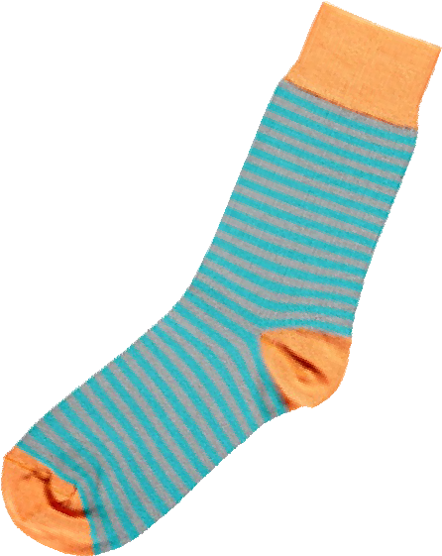

My

Weekly Record

Sheets

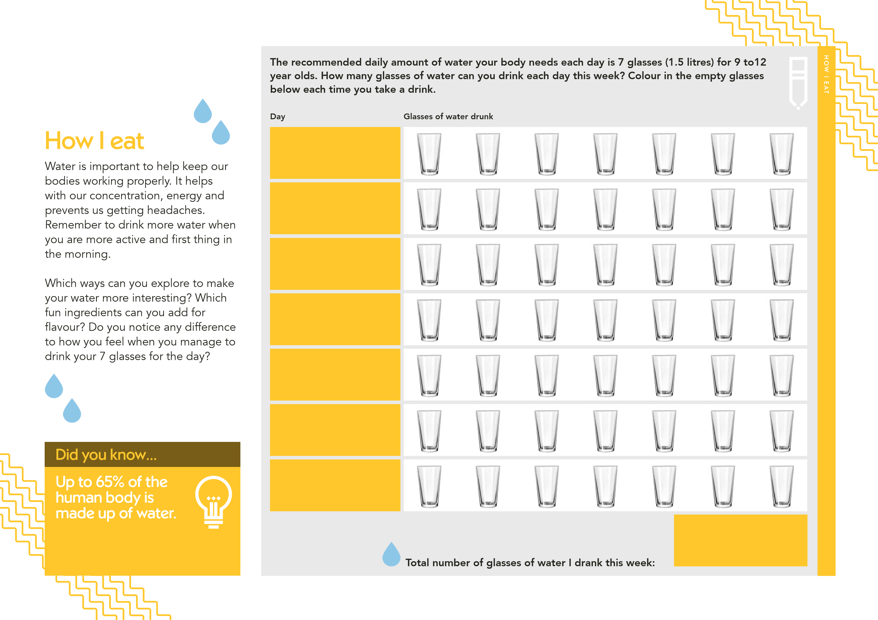

Moving is essential to our health.

Not only can exercise keep us fit and

boost our immune system, it helps

us to feel happy and positive. Aim

for one hour of physical activity each

day that gets you breathless. Try to

include exercises that involve impact

(

like running, jumping, skipping).

What new ways did you come

up with to be more active? Aim

for different movements to make

this fun. Can you share your ideas

with friends? Try to move regularly

throughout the day – not sitting still

for longer than an hour at a time.

How I move

**Complete this exercise chart for a whole week. How many minutes of physical activity did you do each**

**day this week? Are you working all your muscle groups with different types of activities?**

**Day**

**Type of activity**

**Start time**

**Finish time**

**Total time of activity**

HOW I MOVE

**Total time exercised this week:**



Did you know…

Yoga is good for

stress relief, as well

as strength, balance

and flexibility.

How we feel has an effect on our

mood, our thoughts, our bodies

and our behaviours. It is important

to recognise our emotions and

when / why they are happening.

There are things you can do to lift

your emotions to more positive

ones. Exercise and sleep make a

big difference to how we feel.

What changed when you felt better

compared to when you weren’t

feeling as good? What did you

do to lift your emotions to more

positive ones?

How I feel

**Take time this week to think about your emotional wellbeing. Draw a new emoji each day**

**expressing how you are feeling and tell us your reasons for feeling that way.**

**Day**

**Today I felt…**

**Today I felt…**

**Today I felt…**

**Today I felt…**

**Today I felt…**

**Today I felt…**

**Today I felt…**

**This week I mainly felt…**

HOW I FEEL

Did you know…

Laughter can

improve your

memory because it

reduces the stress

hormone cortisol which

can limit our brain power.

**Day**

**Day**

**Day**

**Day**

**Day**

**Day**

Sleep is vital for our overall

wellbeing, on average we should

sleep for over a third of our lifetime!

It helps with growth, brain function

and mood and you should aim for

10-11

hours of sleep every night.

Think about the quality of your

sleep and ways you could improve

this. Was there a reason you didn’t

sleep as well as you could have?

Are there things you could do like

reading, turning off screens earlier,

relaxation exercises or writing down

your thoughts or ‘to do’ list on a

notepad next to your bed?

How I sleep

Did you know…

Good sleep can

help us grow and

become stronger

as it increases the

release of important

growth hormones.

**Complete this sleep diary for a whole week. How many hours of sleep did you get this week?**

**How can you improve on the quality of your sleep for next week?**

**Total hours slept this week:**

**Day**

**Time I went to bed**

**Time I woke up**

**Total hours slept**

HOW I SLEEP