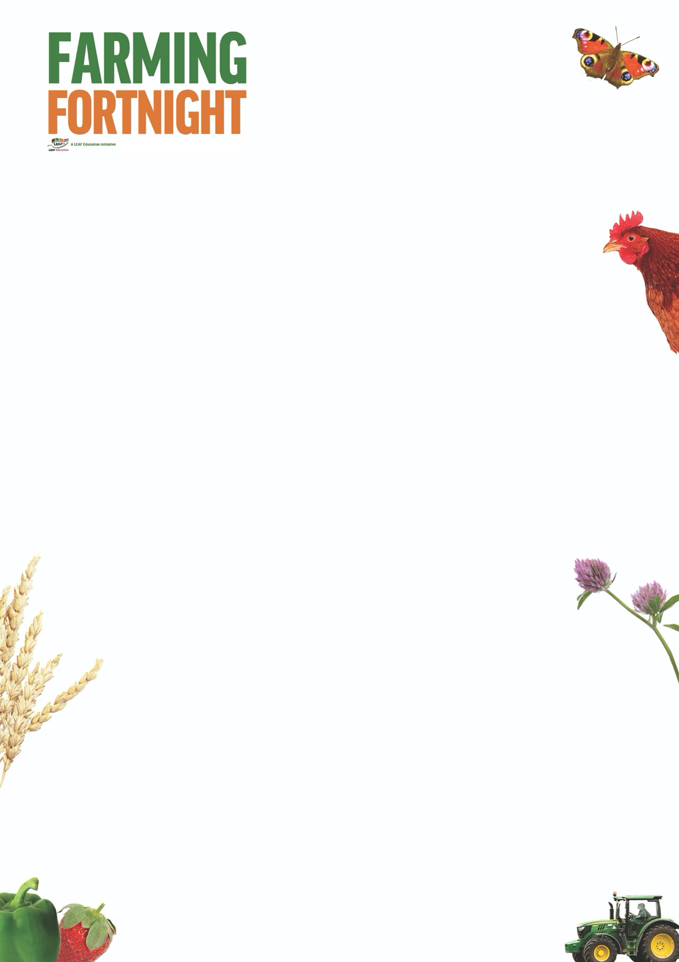

**Woodland: Primary**

This session allows pupils to consider what a woodland area is, what it is like in a wood and why woods are so important to us. Depending on the age and ability of your pupils, the activities in the EYFS and Secondary section can easily be adapted. The Tree Survey activity in the Secondary section may be an appropriate activity for Key Stage 2 pupils.

**Introduction**

* What is a wood?
* What would you find in a wood?
* Has anyone been to a wood?
* What was it like? Or, what do you think it would be like if you haven’t visited one?
* Why are woodland areas important?
* Useful pictures are in the Primary woodland PowerPoint resource

**Activity Ideas**

* **Why are woodland areas so important?** Ask the pupils to come up with a list and write it on the left side of a piece of paper. Fold the piece of paper in half and cover their first list. Then watch the video <https://www.youtube.com/watch?v=q_dhXbLj9mE> “Animating Forestry” . After watching the video, ask the pupils to make another list on the blank side of their paper. Compare the two lists. How many points did they get right on their first list? Did anything surprise them having watched the video?
* There are plenty of activity ideas at <https://www.woodlandtrust.org.uk/naturedetectives/> (make a bird feeder, leaf art, blossom collage, giant nature letters)

**Further Links**

**LEAF Education** <https://education.leafuk.org/>

**Farmer Time** <https://leafuk.org/farmertime/home>

Apply for your free tree<https://www.woodlandtrust.org.uk/plant-trees/free-trees/>