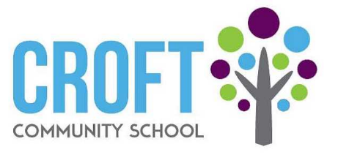
Wellbeing Newsletter
October 2021

We need YOU!
We need a group of parents/carers to be part of our ‘Change Group’ in School and ensure that wellbeing for your children is at the heart of the school. To find our more information please contact Lucy Herkes on 01207 234527 or l.herkes@croft.school

Change Group
The following staff are part of the Wellbeing Change Group, committed to ensuring that wellbeing is at the heart of everything we do at Croft Community School. Feel free to contact any of us if you have any concerns, questions or ideas.
Miss Herkes, Miss Quinn, Miss McGladdery, Miss Copestake, Mrs Fortune, Mrs Kennedy, Mrs Winship, Miss Virtue

Wellbeing Award for Special Schools
We are currently in the process of applying for a Wellbeing Award. This award focuses on changing the long-term culture of the whole school. Using an evidence-based framework to drive change, it will help deliver staff and pupil wellbeing, review staff training, and revise policies. This award will ensure that mental health and wellbeing sit at the heart of school life.

Key Dates  10th October – World Mental Health Day  Keep an eye on our newsletters and the FB page with dates to attend parent wellbeing sessions! | Support Services  MIND – provides mental health information and support www.mind.org.uk  SHOUT – 24/7 text support. Text ‘SHOUT’ to 85258  Young minds parent helpline – advice, emotional support and signposting about a child or young person 0808 802 5544 from 9:30am - 4pm, Monday – Friday  Mindful schools – fee online mindfulness classes New! Mindfulness of Emotions - Free: Online Mindfulness Class for Kids! - Mindful Schools  Rollercoaster support group – group for parents/carers who are supporting a child or young person with any kind of emotional or mental health problem County Durham's Families Information Service | Rollercoaster Support Group (countydurhamfamilies.info)
Conversation Starters

Talking to your child about how they are feeling can be tough, especially if you are concerned that they are having a hard tie. You might not know whar to say, or feel worried about how your child will react. It doesn’t matter what topic the conversatio startes with – it is about the opportunity it gives you to talk about feelings and provide comfort. Whilst you are chatting about something else or doing an activity together, what could be the best wat to encourage your child to open up? Have a look at some conversation starters.
Here are some things you could ask to get the conversation started:  What was the best bit of your day?  Was there any dificult parts to your day>  What did you do today that made you proud?  How are you feeling?  What would you like to talk about? | If your child is having a hard time, you can try to find out how they would like to be suported by asking gentle questions like:  How can I support you through this?  Do you want to talk about what is going on?  Is there anything you need from me? Space? Time to talk? Time to do something fun?  Did you have any problems today? What helped?
“Is there anything you need from me? Space? Time to talk? Time to do something fun?”
Suggestions?  The next wellbeing newsletter will be out in November. If you have any comments or suggestions about what you would like to see in it, please let Miss Herkes know via l.herkes@croft.school | 