12th October 2022

Dear Parents and Carers

I am writing to you with regard to some of the changes we are making to our curriculum and to how we use homework to reinforce the learning that is taking place in school.

During lessons all teachers in both Primary and Secondary will be following the same lesson structure, that or recap, present, apply, and review, this will be the same across all Key Stages and across all subjects. The aim of this is to make a uniformed approach to teaching and learning that the pupils will become familiar with and will be able to transfer from one subject to another.

The recap part of the lesson will focus on ‘checking’ pupils recall of the previous knowledge that they have gained, what did they learn from previous lessons and what can they recall and use to demonstrate understanding.
The present part of the lesson is where the teacher will deliver the new information to the pupils, this will be what each teacher wants the pupils to learn during the lesson.

The apply part of the lesson is where the pupils will complete a task linked to the present part of the lesson and where they apply the knowledge that they have gained.

The review part of the lesson is where the pupils knowledge will be checked to see if they have gained the knowledge from that lesson and if they understand it.

All classrooms have visuals in them so that pupils become familiar with this language and what it entails. These visuals are also on display around school to reinforce this lesson structure.

For the first time we are going to introduce regular homework at Croft. This will be sent home at the beginning of every new half term and will consist of some of the key vocabulary that pupils are going to encounter during their lessons across all subject areas. It will also enable you to see the topics that the pupils are going to be studying across all of their curriculum. This homework will consist of Tier Three words, words that are associated with a particular subject and that pupils will be learning as they progress through the curriculum.

I would like to stress that this homework is not compulsory and pupils will NOT be sanctioned if they do not complete it. We fully understand that for lots of our pupils homework can cause a great deal of anxiety so if pupils complete homework they will receive Dojos depending upon the amounts of homework that they complete. Pupils will be required to either learn the words and/or complete a definition of what the words means as well as include the word in a sentence. This will be very much dependent upon the age and levels of attainment of individual pupils, pupils will receive different types of words and amounts of words depending upon their ability. An example is shown below.

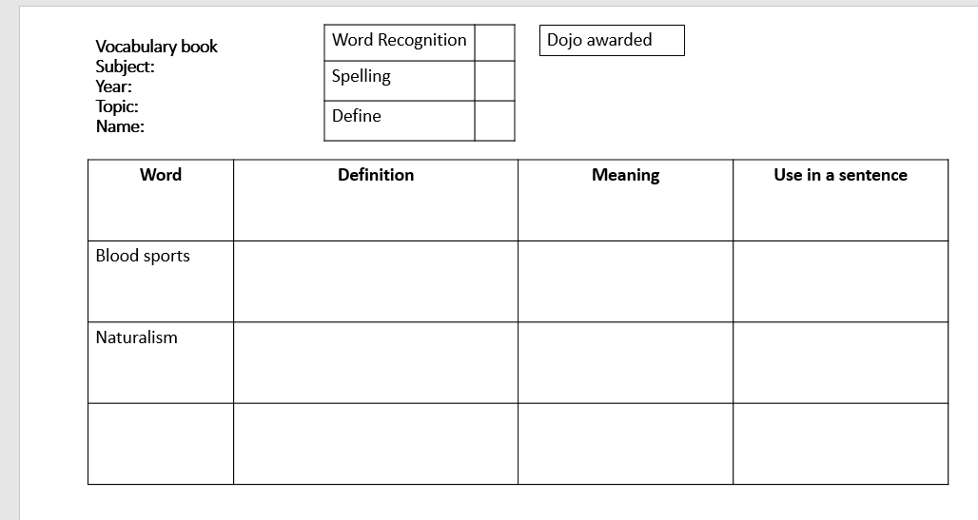

Some pupils, particularly in Year 10 and 11 may require different types of homework due to the courses they are studying for GCSE, BTEC or Entry level.

Should you require any more information about this or have any questions please contact the school via any of the usual methods.

Yours Sincerely
Lee Davis
Head of School

