Thursday 7th September 2023

Dear Parents and Carers

I hope you all had a wonderful Summer and enjoyed valuable time with friends and family. We are delighted to welcome our students back to school this week ready to begin our new academic year and particularly welcome our new students joining us in Year 7. A new school year brings with it the chance for a fresh start, to make new friends and take new opportunities, and we look forward to another year of our students aspiring for greatness and flying high.

We are looking forward to welcoming back all of the pupils as we begin another academic year and this letter is to provide you with updates and changes for the forthcoming year as well as providing you with an annual calendar of events and a list of the school holidays that I hope you find useful.

Exam Results

We were so proud of our Year 11 pupils and their exam results this year, for those parents and carers who didn’t see the Dojo message our 2023 leavers attained 132 Entry Level Certificates, 34 Level 1 qualifications, 9 Level 2 qualifications and 48 GCSE's, a tremendous achievement.

Staffing and curriculum

There will be 16 new members of staff joining us in September, however many of them have been with us on long term supply so there will be no disruption to the classes for your children when they return and form staff and class staff will be setting up the Class Dojo accounts over the next couple of days so you will be able to contact staff via this method. Letters will be coming home in order for you to sign up for Class Dojo should you need to. We will also be introducing some new subjects this year, such as Hair and Beauty and Business studies, as well as introducing something called Commando Joes’ as part of the secondary pastoral progamme and we will be continuing to implement Read, Write, Inc and Accelerated Reader as part of supporting and developing the reading abilities of pupils.

Croft House Points

We will also be starting Croft Dojo House Points from September. All pupils and staff in school will be allocated a house, these will be called House Phoenix, House Dragon, House Centaur and House Medusa, these were chosen by the pupils. There will be a House Captain and Vice-Captain appointed on Wednesday as voted for by the pupils in each house and there will also be inter-house competitions throughout the year. Pupils will collect Dojo points in the usual way and these will be collated and presented to the pupils during house points assemblies once every half term, extra points will be awarded during the inter-house competitions.

Parents Evening

We will also be trialling a booking system for parents’ evenings where secondary pupils will be able to book a time slot with individual teachers similar to the system that we operate in the primary department. There will be more details of how to book these closer to the parents’ evenings.

Nut Free school.

Can I just remind you that we are a nut free school as far as possible as we have several pupils who have severe allergic reactions to nuts. Can you please consider this when sending in food for packed lunches or snacks.

Safeguarding and attendance Team

We have 5 members of staff on the safeguarding team at school led by Ms Elcock, who is Deputy Head and also designated safeguarding lead. Deputy safeguarding team consists of Mrs Ridley who is also Assistant Head of Primary, Mrs Beckham, who is also assistant head of Secondary, Mr Harrison who is also behaviour lead and Mrs Birbeck who is responsible for running the ‘Bridge’ in school. Miss Raine who is a member of the safeguarding team and will also be working with pupils and families who require support with attendance.

Calendar of Events 2023-2024

In the table attached with this letter is a list of key dates and events for this academic year and we will also send out further details about these events should they be required. As you can see there are lots of events planned over the year but should you require any more details or require more information please get in touch via Class Dojo, Facebook page, the school office or via the school website.

Date | Event | Participants
22nd September | Garden Harvest Afternoon | Parents/Carers of all pupils
27th October | Mental Health awareness day | All pupils and staff
6th November | Parents Evening | Parents/Carers primary and key stage three pupils
13 November | Parents Evening | Parents/Carers primary and key stage four pupils
13th December | Primary Nativity Play | Parents/Carers of Primary pupils
14th December | Christmas dinner and jumper day | All pupils
18th December | Christmas Rewards Day | All pupils
19th December | Christmas Reward Day X2 | All pupils
22nd January | National Chocolate cake and fun at work day. | All pupils
29th January | Parents Evening | Parents/Carers primary and key stage three pupils
5th February | Parents Evening | Parents/Carers primary and key stage four pupils
16th February | Mental Health Awareness Day | All pupils
8th March | International Women’s Day | All pupils
17th March | Sports Relief | All pupils
17th March | Interhouse competition | All pupils
28th March | Easter Rewards/Easter Market Day | All pupils and parents and carers
28th March | McDonalds Reading Rewards | Pupils who are nominated by staff
28th March | National Autism awareness day | All pupils(Pastoral Day)
23rd April | World Book Day | Primary Pupils
13th May | Interhouse competition TBC | All pupils and staff
24th May | Mental Health Awareness activities | All pupils and staff
17th June | Pride Celebration assembly and event | Whole school
20th June | School Prom | Staff, pupils parents and carers of Year 11 and Year 10
28th June | Year 11 leavers assembly and last day | Year 11 staff and pupils
5th July | Croftonbury Fayre | Whole school event/staff and parents and carers
8th July | Parents Evening | Parents/Carers primary and key stage and Year 10 pupils
15th July | Parents Evening | Parents/Carers primary and key stage and Year 10 pupils
22nd July | Rewards Day | Whole school

School Holidays

I’ve also attached a copy of the school holidays for this academic year, these will also be available on the school website.
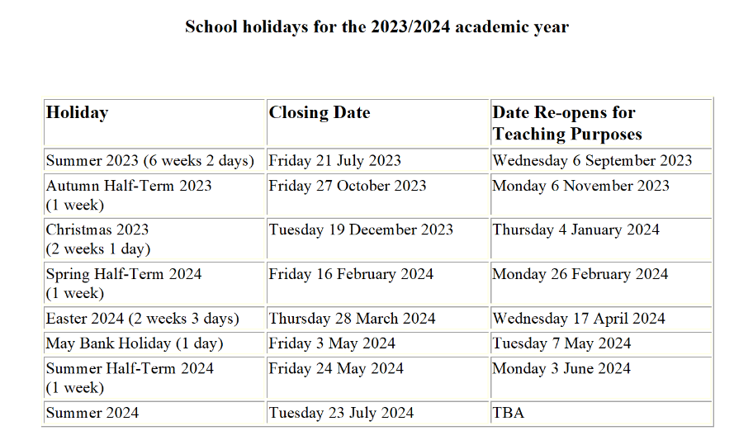

I hope you find this useful but if you require any more information please contact the school via the usual methods, using Class Dojo, the Facebook page or by contacting the school office.

Yours Sincerely
Lee Davis
Head of School

