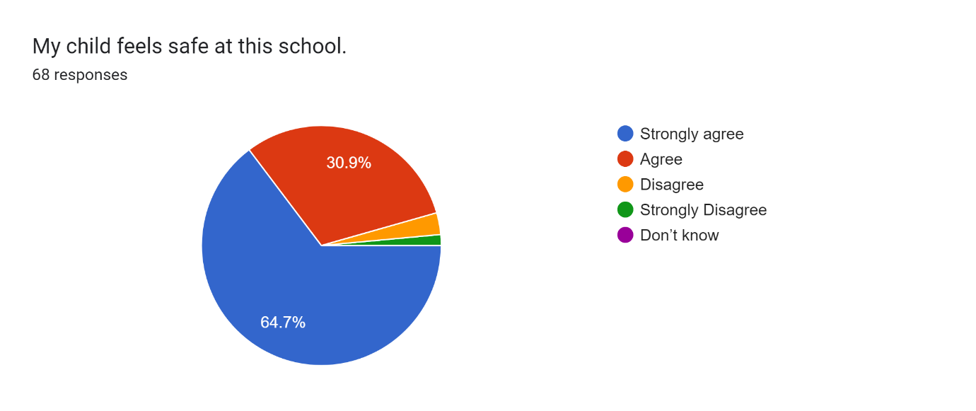
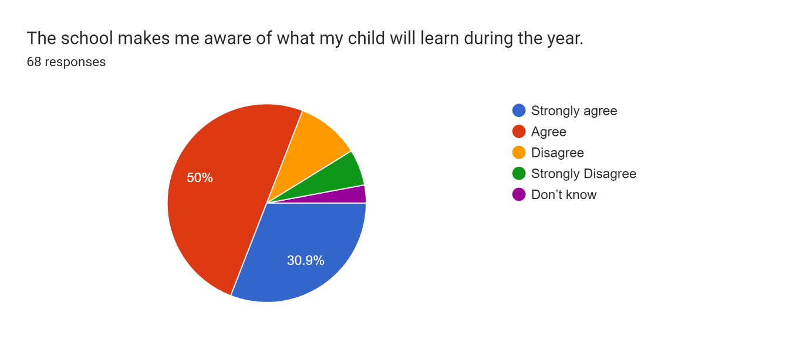
Response/Actions
Most classes post on Class Dojo the learning which is taking place in each class, but to make this consistent across the school each secondary class will produce an overview of the topic that is being studied in each subject every half-term or term depending upon the subject. Primary classes will also be publishing a similar version across the subjects that are studied. This will commence after February half term.
There will also be some homework starting after the half term holidays which is all about the key words that are being studied in each subject and topic. We have also taken onboard the comments regarding the school reports so next year the end of year report will include a pastoral report related to the categories that parents and carers have identified. These include:
Strengths and areas of development
Behavior
Peer relationships
Staff relationships
More personalised reports
Development of social skills.

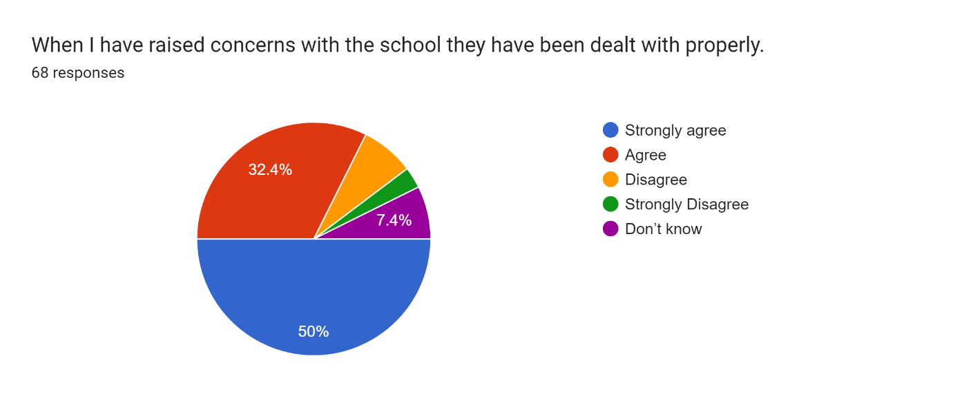
Response/Actions
We have an open-door policy at Croft and we hope that if anyone has concerns or queries they can ask any member of staff and we will try our upmost to solve any concerns raised. We follow school policies, which can be found on the school website and procedures as set out by Durham County Council. The senior leadership team at Croft Community School are Mr Tweddle (Executive Headteacher), Mr Lee Davis (Head of School), Ms Elcock (Deputy Head Teacher), Mrs Ridley (Assistant Head Primary), Mrs Beckham (Assistant Head Secondary).
Parents can raise any concerns with form and class staff via Class Dojo and can phone the school at any time. Contact details are available on the website.
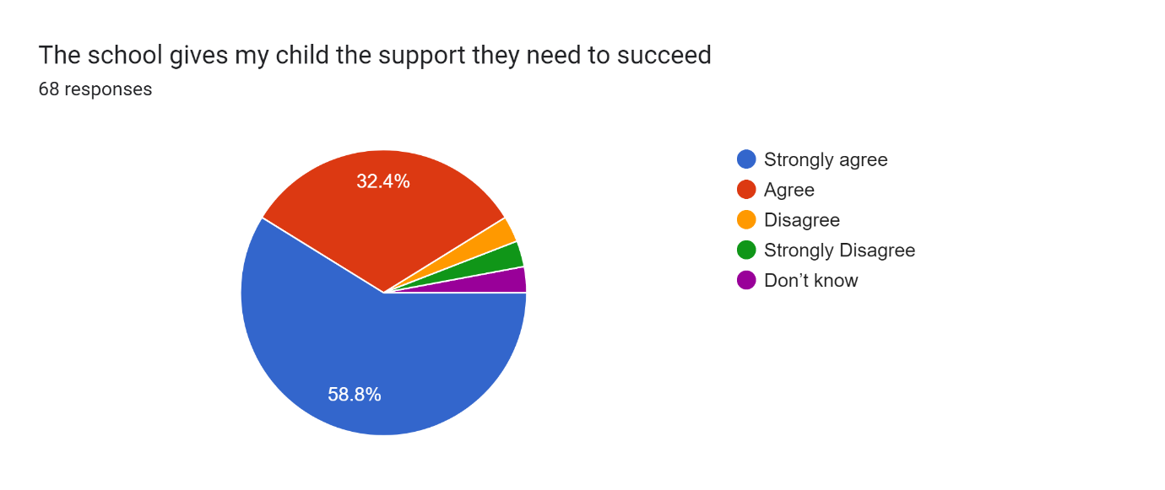

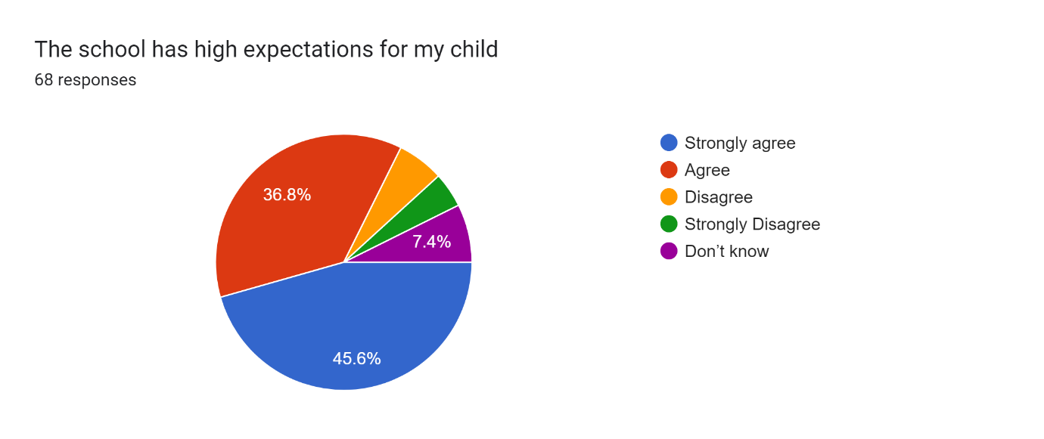
Response/Actions
At Croft, we have high expectations of every child in our care. We set class charters each year and expect every child to try their best in all they do. We offer a broad curriculum and embrace initiatives to develop the whole child. We have a huge emphasis on reading and have invested heavily in training of staff and purchasing resources for the Read Write Inc, Fresh Start and Accelerated Reader programmes.
Our expectations follow key principles and values that are listed below.
Ready to Learn
Respecting the needs of others
Always try your best
Following staff requests
Speak positively to others.
Right Place, Right Time
Pupils achieve awards during assemblies for demonstrating either improvements or excelling at these values. We expect pupils to follow these expectations but we also set high standards for behaviour and for trying their best in their academic work. We also have high expectations of pupils gaining as many qualifications as possible and developing their lifeskills and social skills.

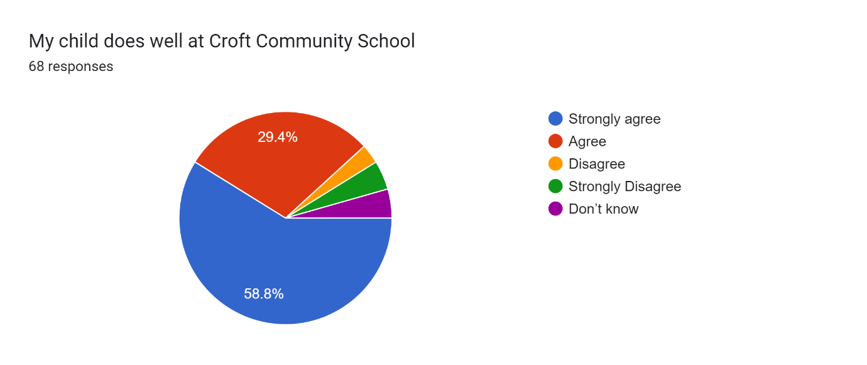
We feel that all of our pupils perform extremely well at Croft but we’d be interested to gauge why some parents feel that pupils don’t do well. Pupils progress well in terms of developing their reading and spelling and develop their knowledge across the curriculum that they study.
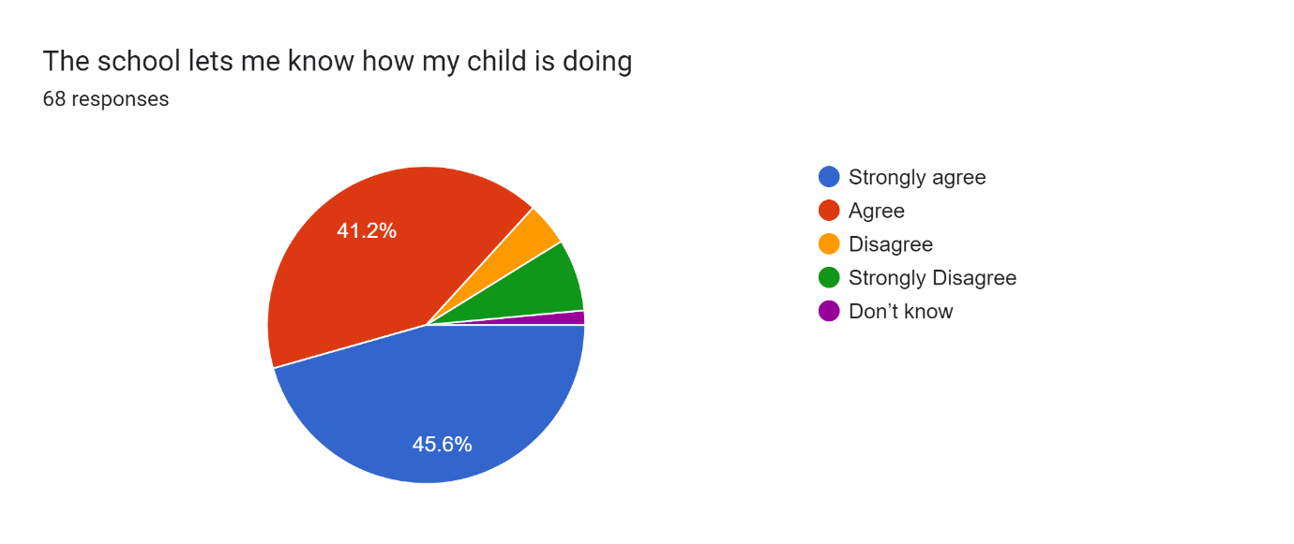
Response/Actions
We hold parents’ evenings 3 times a year and accommodate telephone appointments for those who cannot attend face to face. We use Class Dojo to update parents as to how children are doing in class. We write and issue end of school reports and hold annual EHCP reviews. Hopefully, the end of school report will be more informative with the issues that parents have raised as well as closer and more informative information shared via Dojo.

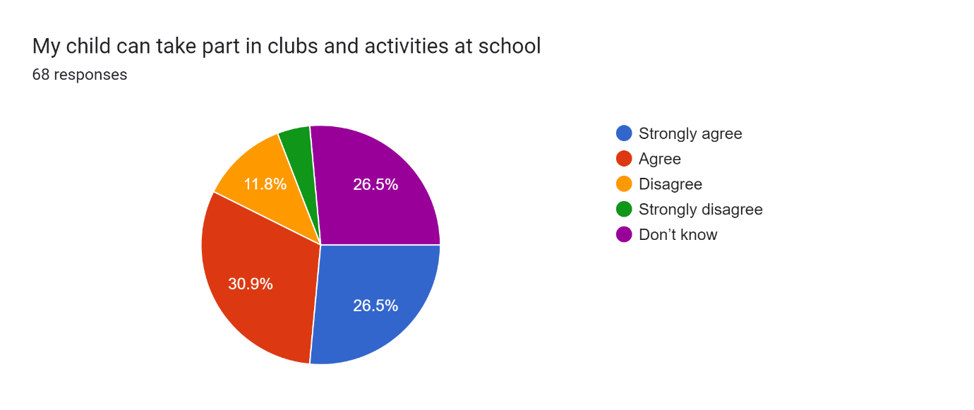
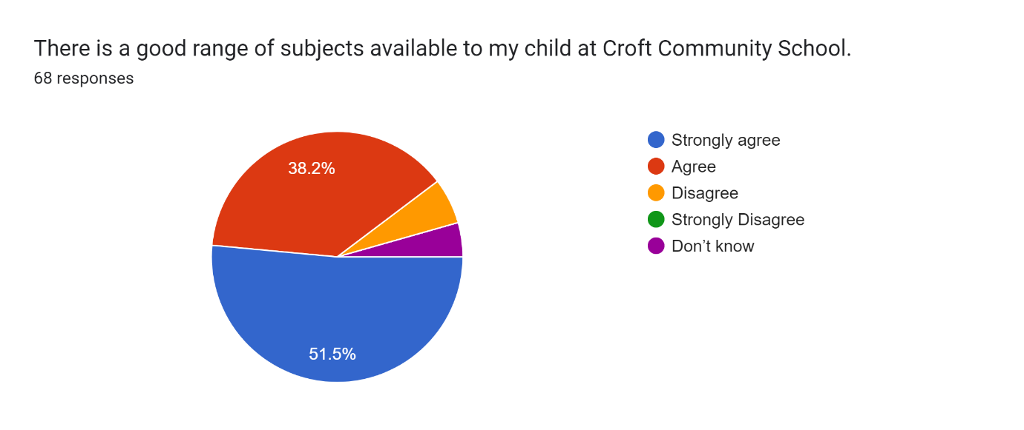
Response/Actions
As part of our enrichment programme, there are clubs and activities offered to each child in school e.g climbing, newspaper club, gardening, rebound etc. We also offer music lessons by music specialists. All children choose from a range of PESSPA activities to participate in during playtimes. Lunchtime clubs are available such as Lego club. We acknowledge that there are no after school clubs and this is an area we are hoping to address in the summer term.
Response/Actions
At Croft, we follow the National Curriculum for all key stages. We also offer alternative pathways for those who require this and offer vocational subjects such as car mechanics, horticulture etc. We also teach British Sign Language and Makaton. One of the key components of our curriculum is reading which we do at all levels. We also have dedicated lifeskills and preparing for adulthood lessons. We consider the interests of individual pupils and will offer subjects in Key Stage 4 which match some of these interests e.g. we have had pupils go to Tanfield School to join particular GCSE classes, we have taught a child different languages such as Italian, Mandarin at GCSE level and facilitated tutors.
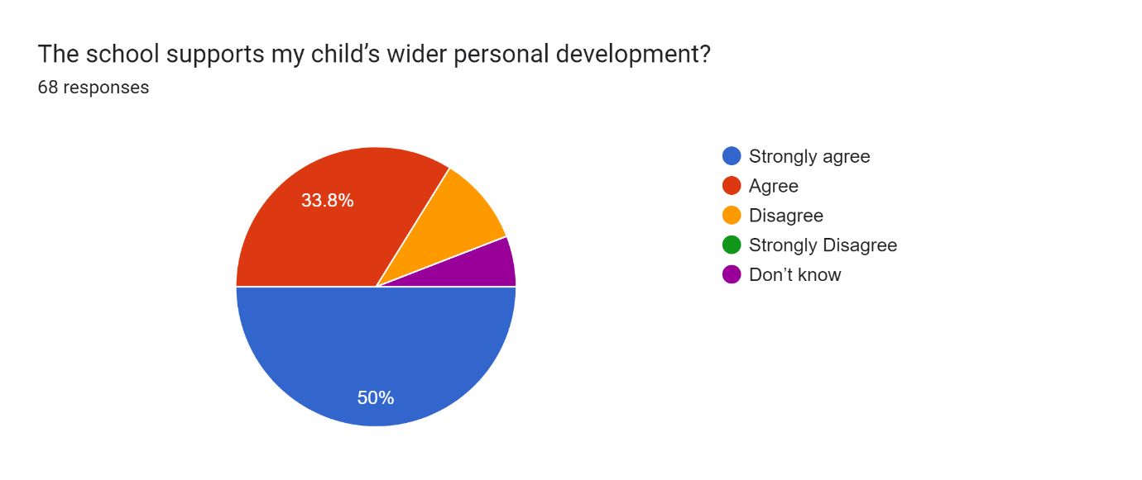
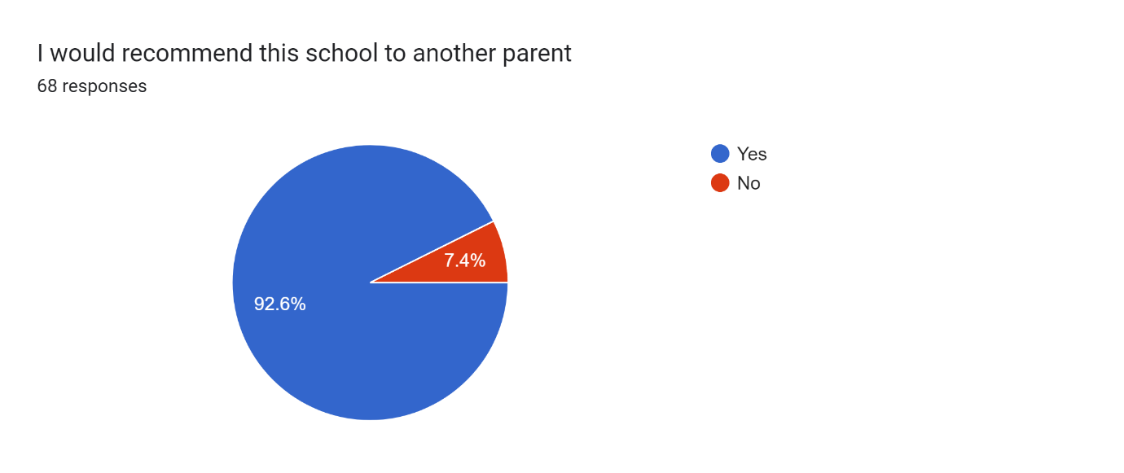
Response/Actions
Children follow a well-planned pastoral programme in addition to the PSHE curriculum. We hold weekly assemblies where different themes are explored. Croft Community School is a Rights Respecting School (RRS UNICEF UK) where children know their rights and how to express these. Each classroom has a RRS charter displayed. We celebrate differences and diversity, we are hoping to achieve a LGBTQ+ silver award and have conducted pupil surveys, parades, activity days etc. We have our own pupil voice group who meet regularly to discuss and share how to improve school. This group are also involved in interviewing candidates for employment vacancies in school. We set Preparing for Adulthood (PFA) outcomes on individual EHCPS. We offer instrument lessons through the music service. At Croft, we also advise on good mental health strategies.
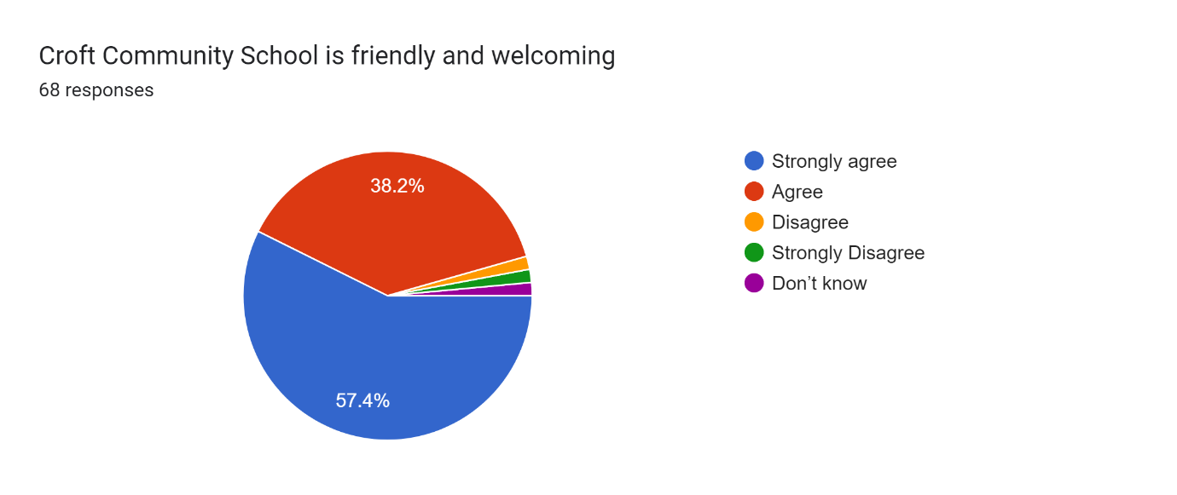

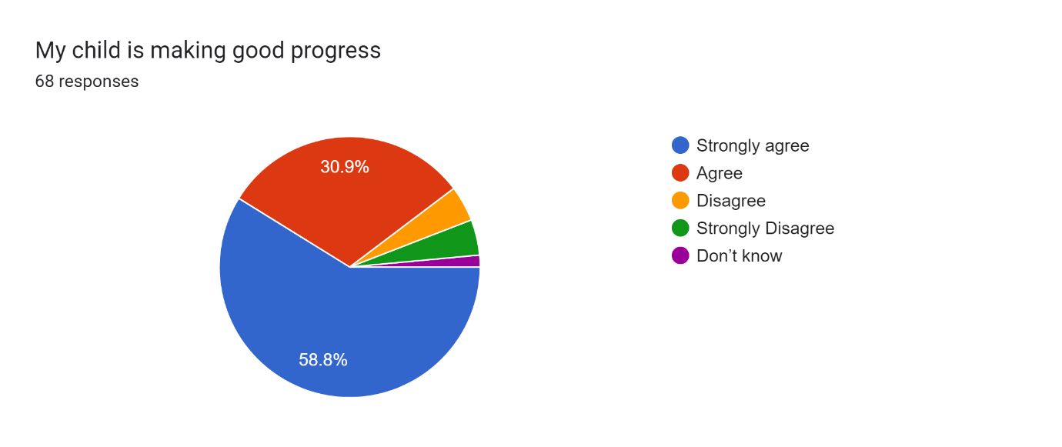
Responses/Action
At Croft, we have robust assessment procedures which we use to assess the knowledge gained in lessons. We assess phonics and reading each half term as well as completing spelling assessments. Teachers use these assessments to inform their planning. We offer daily 1:1 phonics interventions as well as individual interventions for specific areas in English and Maths. We have taken your suggestions with regard to the reports and will ensure that the progress that pupils are making is clearer.

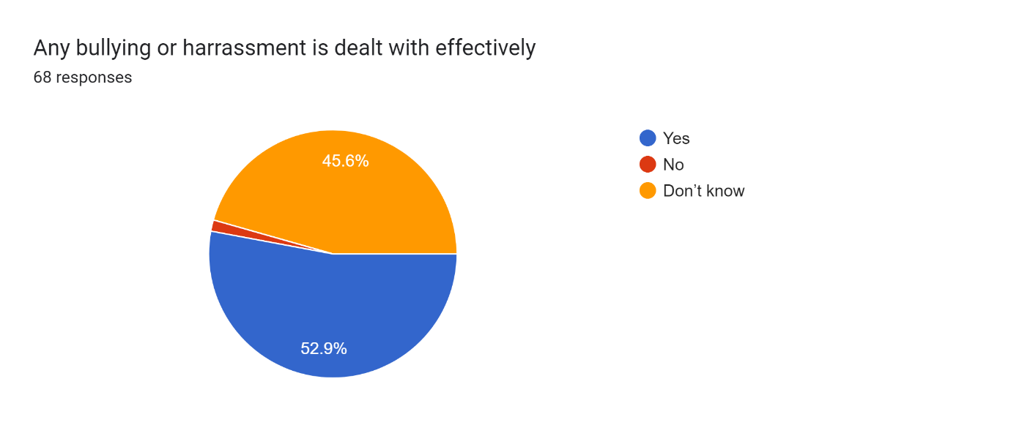

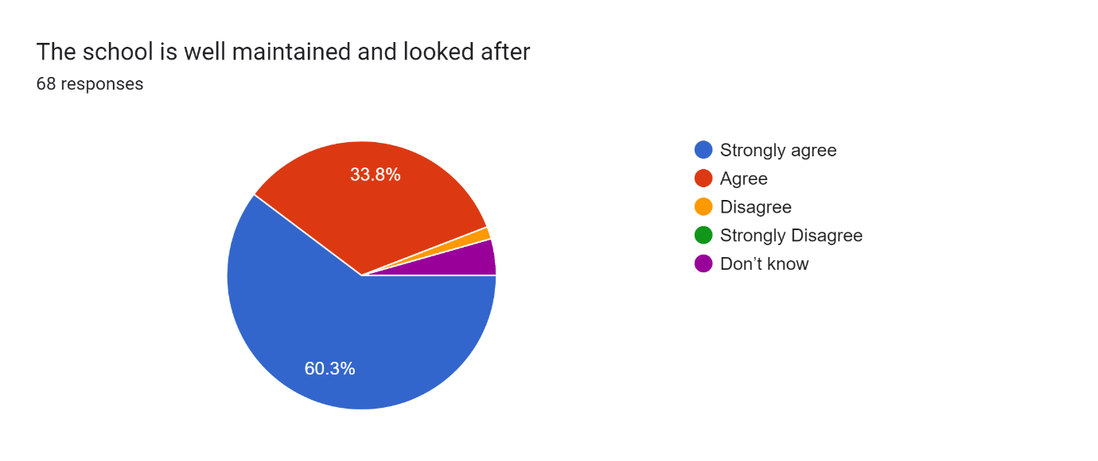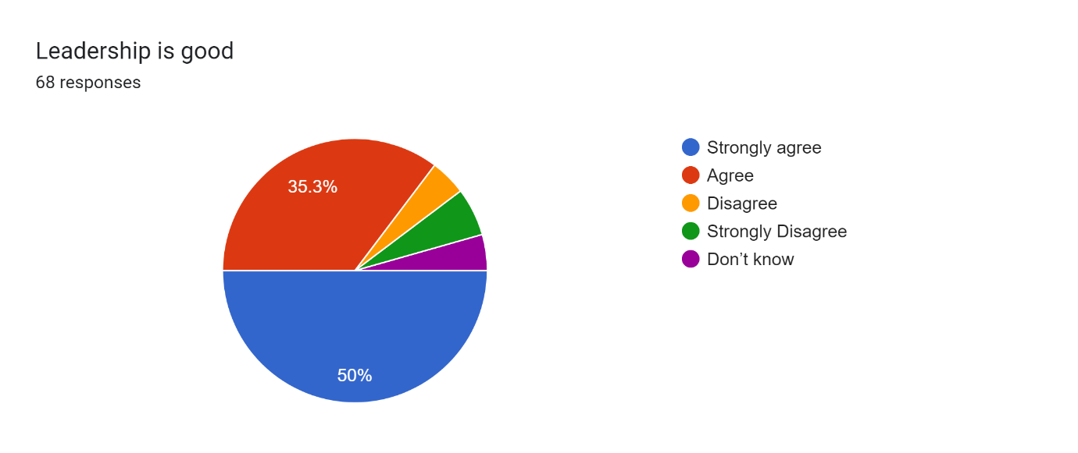

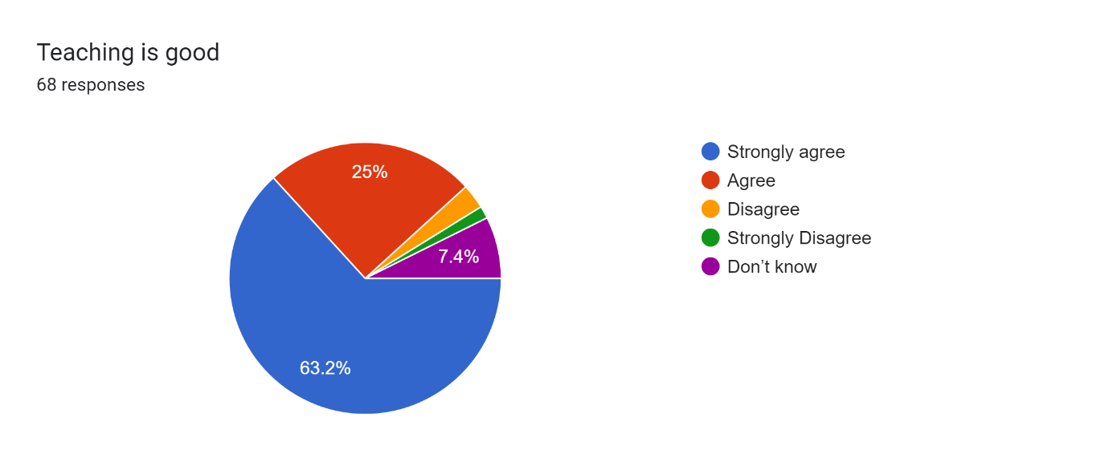
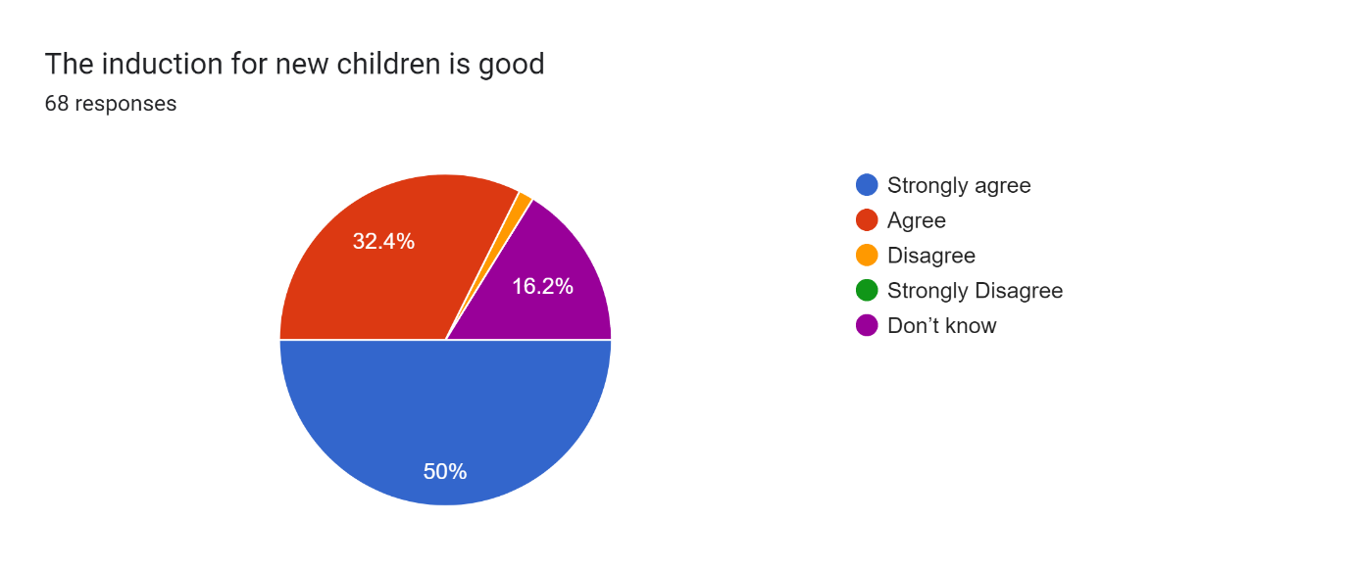
Response/Actions
For those pupils who are new to Croft, we arrange a visit to school. We send home an induction booklet which outlines who keys staff are in school and the environment and routines. We then hold two induction days where new pupils can meet their peers and work in their new classroom. The pupils also stay for a lunch and playtime. Individual induction days and visits are organised for individual parents and pupils.

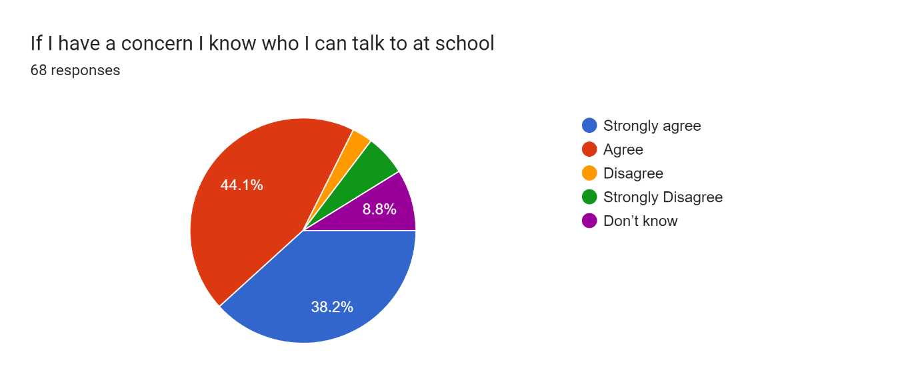
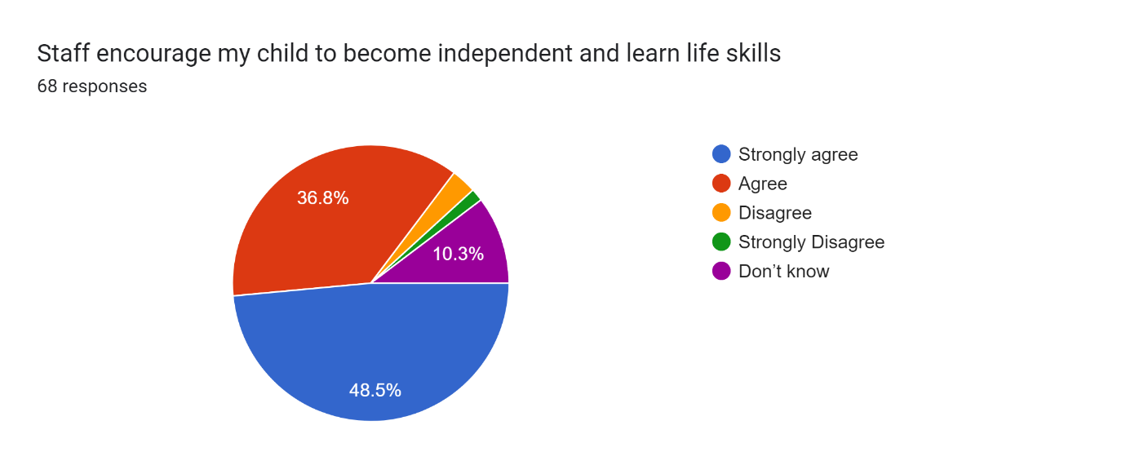
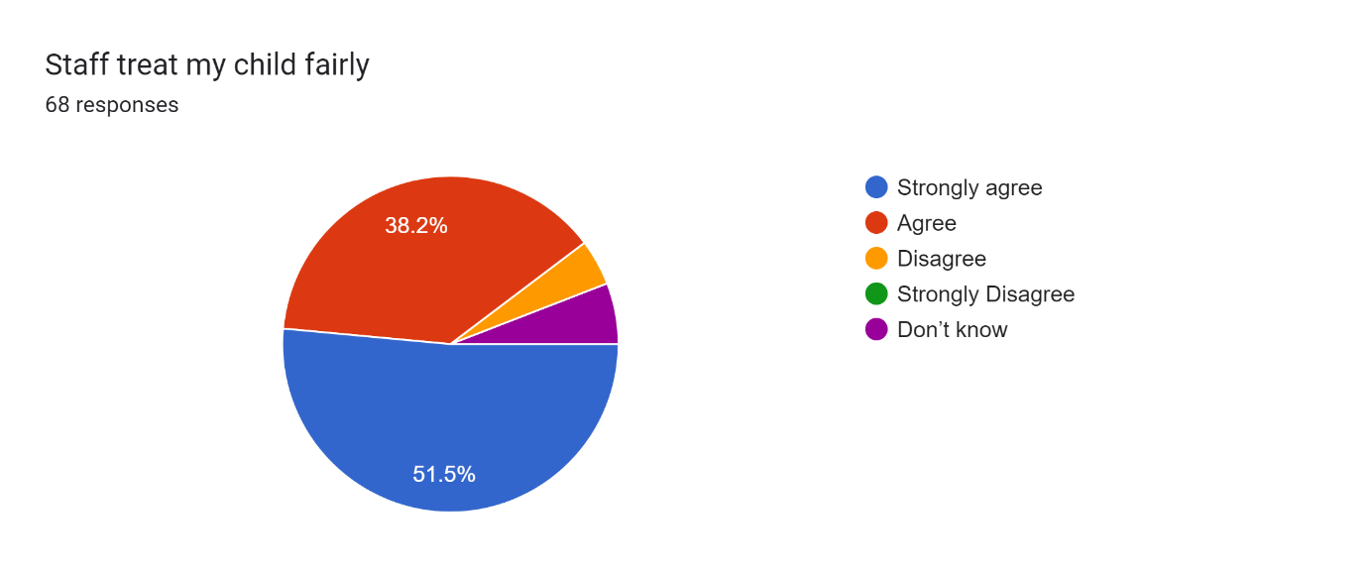
First point of contact is with your child’s pastoral class which can be found on Class Dojo and/or the school website.
Should you have any other concerns the following people are able to be contacted.
The senior leadership team at Croft Community School are Mr Tweddle (Executive Headteacher), Mr Lee Davis (Head of School), Ms Elcock (Deputy Head Teacher), Mrs Ridley (Assistant Head Primary), Mrs Beckham (Assistant Head Secondary).
We also have a safeguarding team that consists of
Our DSLS are:
Vanessa Elcock – Safeguarding Lead
Nicola Beckham – Deputy Safeguarding Lead – Online safety
Rachel Franklin – Deputy Safeguarding Lead – Primary
Mags Birbeck – Deputy Safeguarding Lead
Richard Harrison – Deputy Safeguarding Lead – Behaviour
Alex Raine – Deputy Safeguarding Lead – Attendance
Rebecca Llewellyn – Children Looked After
If you have a concern about a child, report it to a Designated Safeguarding Lead
If you have a concern about a member of staff, report it to the Head Teacher
If the concern is about the Head Teacher or the Executive Head teacher, report it to Clive Hubery, Chair Of Governors.

All pupils in Croft have dedicated lifeskills lessons where pupils learn independent skills such as timetelling, money, travelling independently, being safe in the community, using shops and community facilities. Pupils also have dedicated lessons on a morning where they work towards achieving their EHCP outcomes, these are reported on during a pupil’s EHCP annual meeting. Reading is always encouraged and supported throughout the school day and in every lesson.
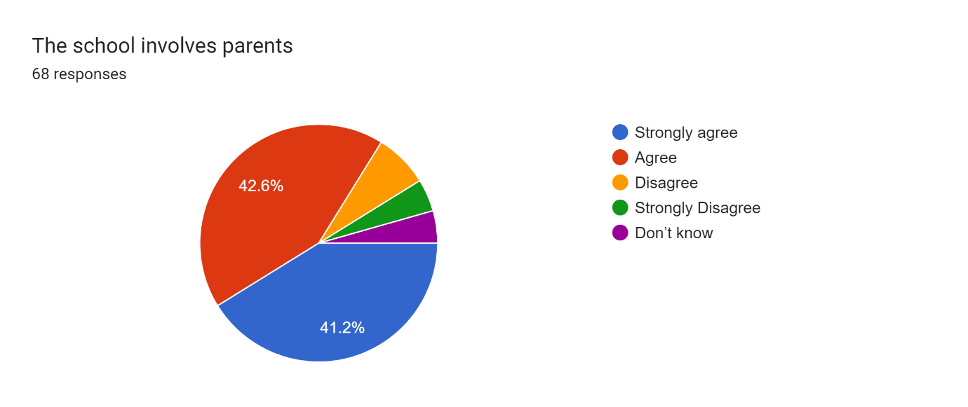
Response/Actions
We encourage a strong working partnership with parents. We conduct anonymous parental surveys, where the results are shared. We have an active parent/teacher association called Friends of Croft Community School (FOCCS) who meet regularly and hold school events such as a Christmas fayre, rewards days etc. We hold meetings to discuss curriculum subjects and initiatives such as Read Write Inc, where meetings are face to face, but we repeat the meeting online. We hold parent evening three times a year. We have Class Dojo as our communication system, where each class has its own Class Dojo and parents/teachers can message and parents can find out what learning and events ars taking place in classes. We have an open-door policy where parents can make appointments to speak to members of staff face to face or via telephone. We have Christmas shows and other events during the year which parents are invited to. Whenever we introduce new initiatives we consult or inform parents via the school website, class Dojo or by the Facebook page.
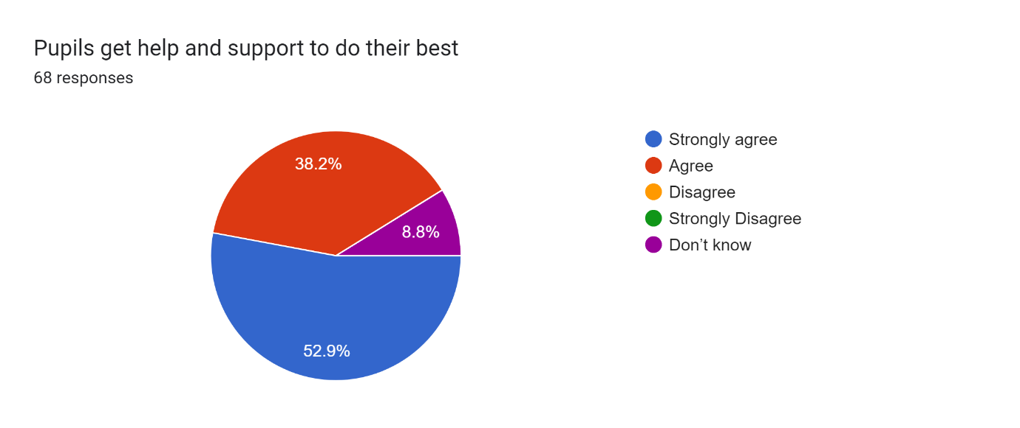
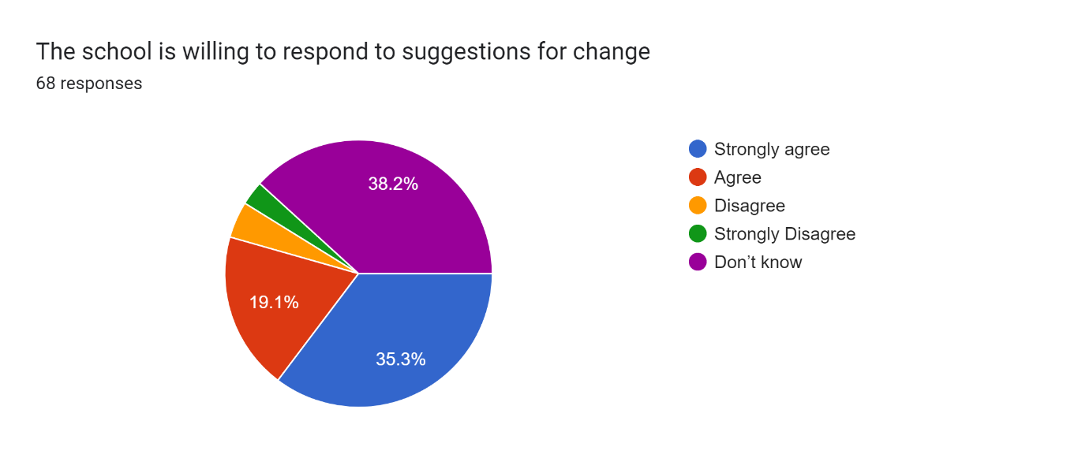
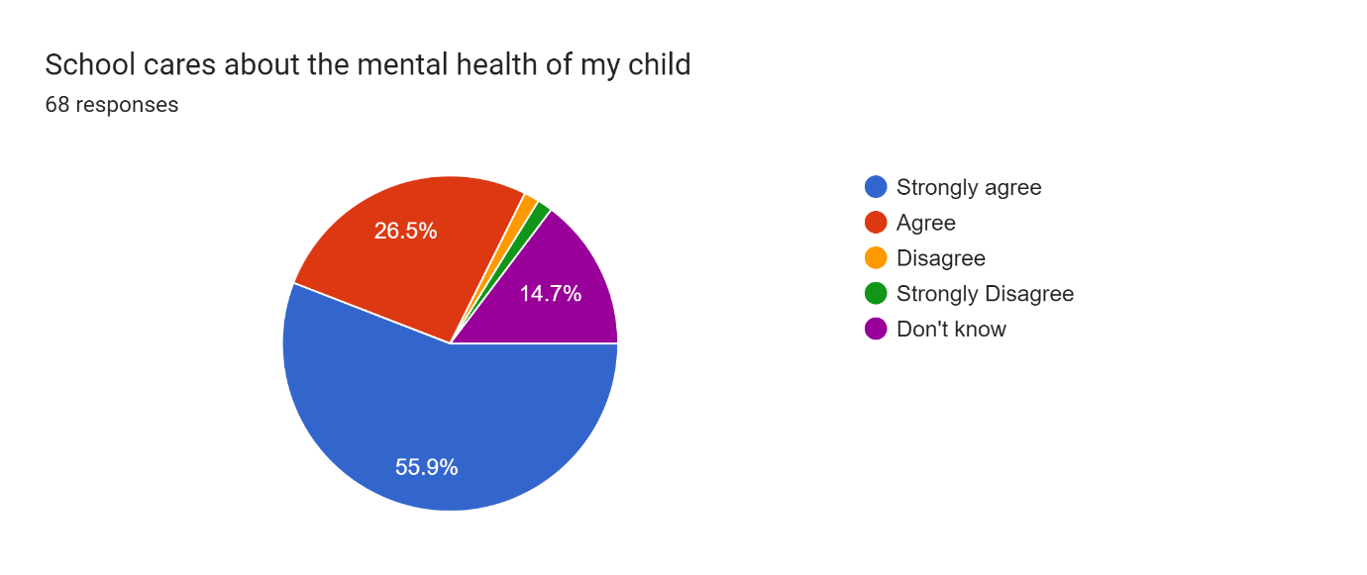
Any suggestions or ideas put forward by parents and carers are taken seriously by Croft school such as suggestions about parent evenings, the school reports, ideas from the PTA as well as from the pupils themselves via the school council and the pupil voice.
The mental health of pupils is also one of the key parts of the school ethos. We have a duty of care to our pupils and as well as supporting them to achieve academically, we also want to support our pupils as a whole. We have a range of support available to pupils to help them manage their mental health positively and have support mechanisms in place such as the Hub and Bridge with Miss Birbeck, we have pupil mental health champions, physical support and counselling sessions, links to professional services such as educational psychologists, peer mentoring and wellbeing services.
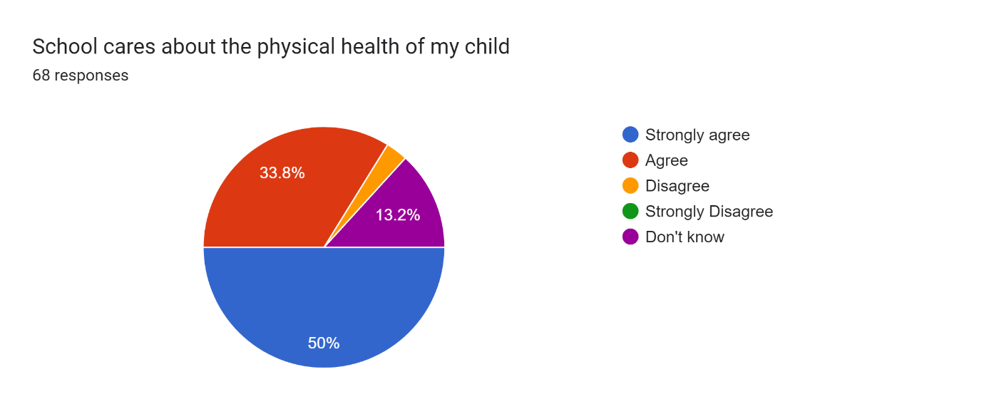

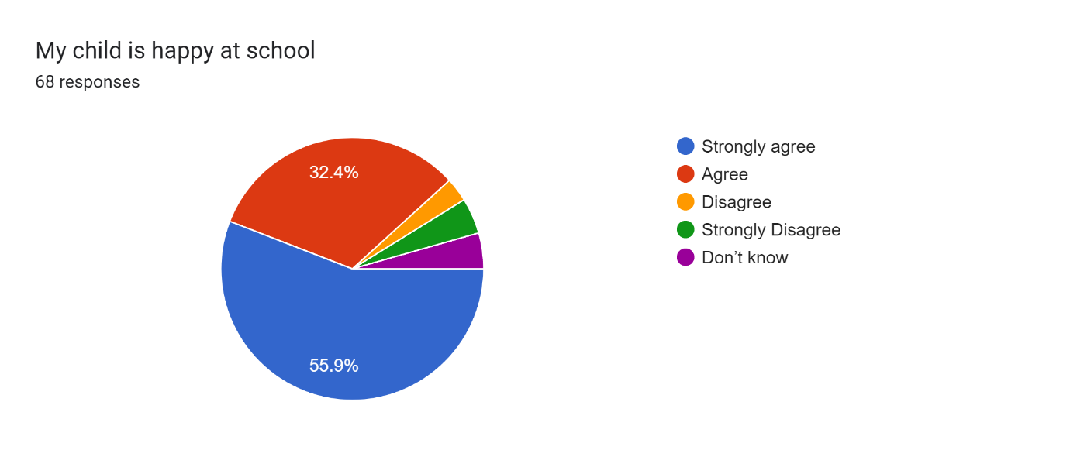
17 responses
How the EHCP is met, what the strategies are in order to fulfil the EHCP
Response: Pupils work towards their EHCP outcomes throughout the year and once a week during lessons pupils and staff record how much progress that they have made toward their targets. In terms of provision, strategies are individualistic, for example if a pupil requires a movement break that is what is provided, if pupils need instructions presented with visuals this happens.
Didn’t like the reports in july. Not personal. Very vague
Poor very basic
School reports were no good this year, not specific enough to your child. No where near good enough to let you know how your child in particular is progressing at school.
Would be nice that both parents get a phone for the reports instead of having the information passes on by the other parent
I’d like comments from all subject & form teachers about how my son is doing I.e strengths, weaknesses, what topics he’s covered this year, what his behaviour is like,
These are addressed earlier in the responses, however we will be including details like this in the end of year report and will be more specific, these will be written by the pastoral class.
………needs to be learning age appropriate topics for ks3 not ks1 subjects.)
All pupils in school follow work that is set at an appropriate level and key stage.
also I think it would be a lot better if you could do reports more than once a year. Maybe a shorter report at the end of each term? (Xmas, Easter and summer) for parents whom can’t make parents evening so we can stay updated as not all teachers reply to dojo messages. Also maybe more updates from teachers on dojo please? I feel very in the dark on what my son is learning.
Clearer information about events happening!
Teachers are only allowed to write reports of up to 250 words a year for each pupil, this is part of their terms and conditions.
I agree the reports were not personal at all,very disappointed with them.
How they are coping in school and any behaviour issues how they are progressing in general
Not very personal and looked awful!
Some photos of work and activities would be good and maybe some information on the social skills learnt.
We have taken on board all of the comments about the reports and we aim to improve these for the end of year reports 2024. Teaching unions state that teachers are to write no more than one report per academic year. Most class teachers post photographs on Class Dojo or the school website so parents can have a flavor of the learning that is taking place during the year.
Events and dates for your diaries are published at the beginning of each academic year both on the school website and on Class Dojo.
We don’t know what is going on in school since the larger classes. There’s no feedback and there seems to be more meltdowns.
Unfortunately. we don’t have a say in the admission of pupils, we are informed by the local authority who is going to given a place.
I personally would like a comment off each subject teacher (sorry I know time consuming) to indicate how my child has coped and done in that subject if they are excelling behind on average to see what I as a parent can help with at home
Please see response above

