19th January 2024

Dear Parents/ Carers

I am writing to inform you about a new initiative after the half term holidays for pupils with regard to homework. At Croft, we are very aware that homework can have both a positive and negative impact on our pupils so I just wanted to make it very clear that homework will always be voluntary but if pupils complete it they will receive Dojo rewards.

Learning new words is a cumulative task that takes place gradually over time. Research shows a strong relationship between word knowledge and reading comprehension. Therefore, we will be sending home vocabulary homework towards the end of this half term in the form of game codes to be played online. Depending upon the topic being covered across all areas of the curriculum, the list of vocabulary will vary either half termly or termly depending upon the topics that are being covered. For example, if Year 8 were studying the Tudors in history they will be learning new vocabulary about this topic whereas in English they might be learning vocabulary associated with a particular novel.

This will allow your child to recap and reinforce the subject specialist words that they have encountered during their learning in school over that half term or the full term depending upon how the teacher has planned the curriculum.

Pupils log onto an internet connected device and visit knoword.com and enter the code for each subject. They can play as many times as they want, and staff will monitor their activity and reward them with dojo points. If you would like flashcards sending home to practice words pastoral class staff can send this home for your child.

1.Follow these instructions in order for your child to log on:

Classroom vocabulary game - Knoword

It should look like this.

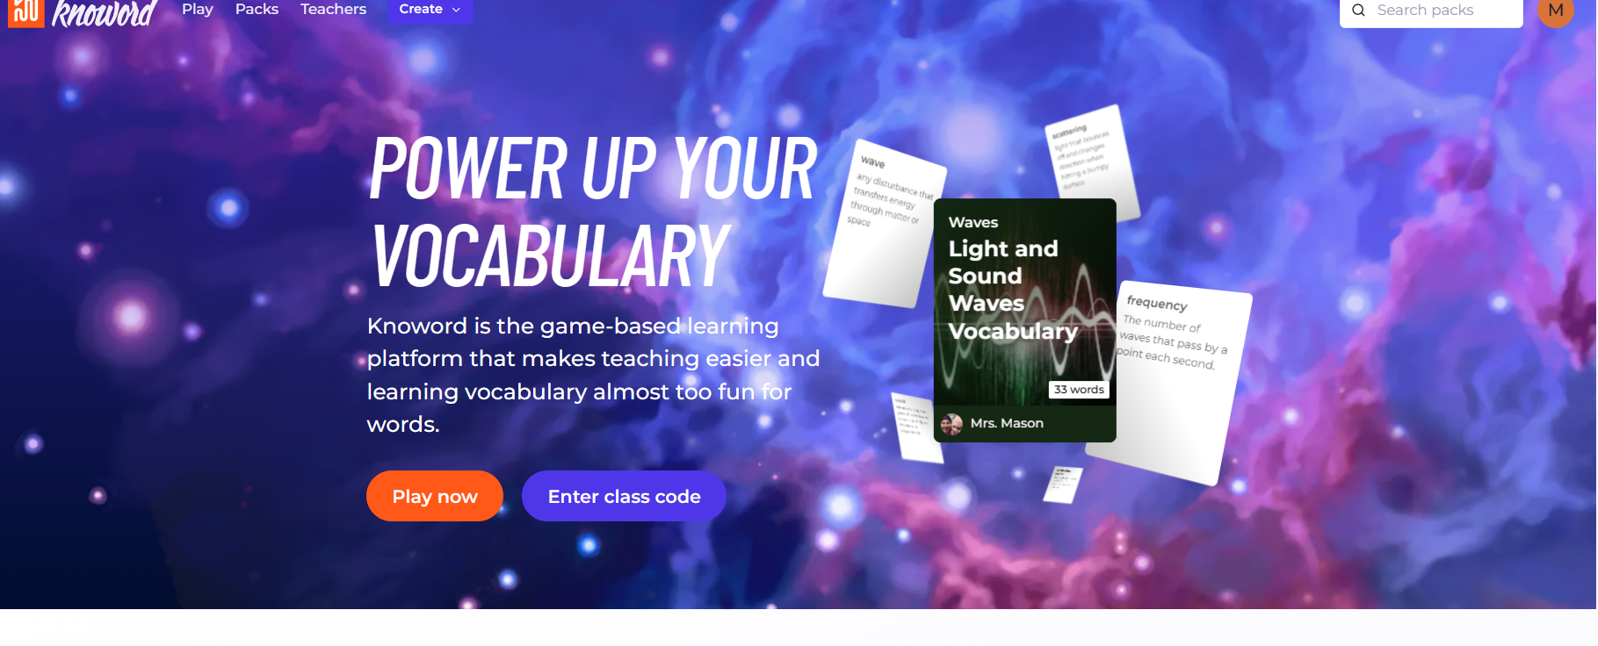
2. Once you have got onto the website you enter the code that will have been sent to you via Class Dojo. You click on this button.

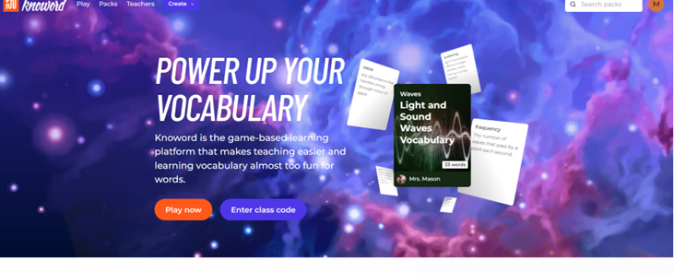
This page will appear:-
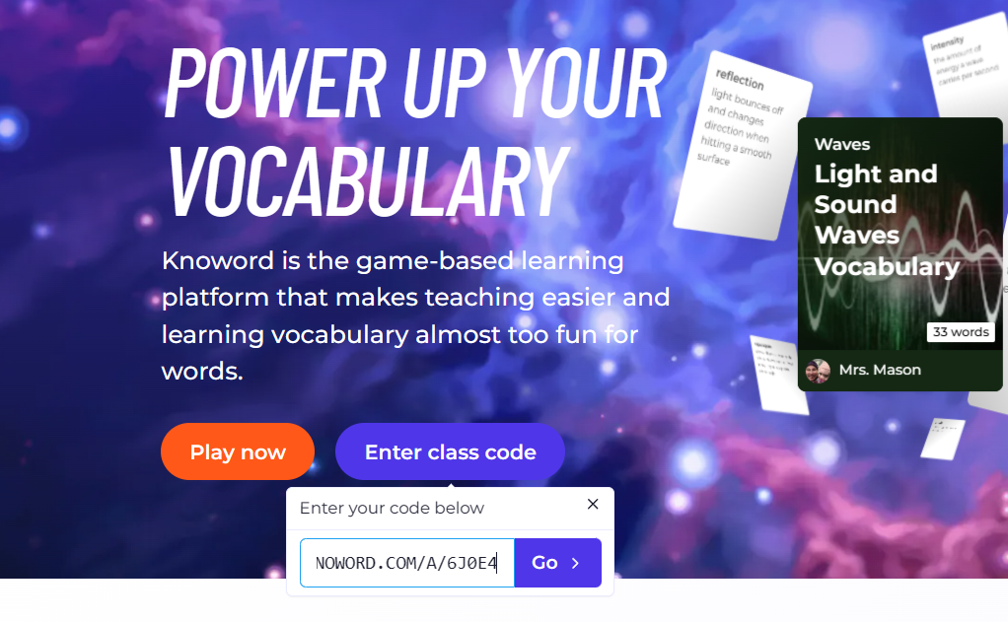
You then just enter the code that you has been sent via Class Dojo, there will be one for each subject that your child studies. Put the code or copy the code into the box.
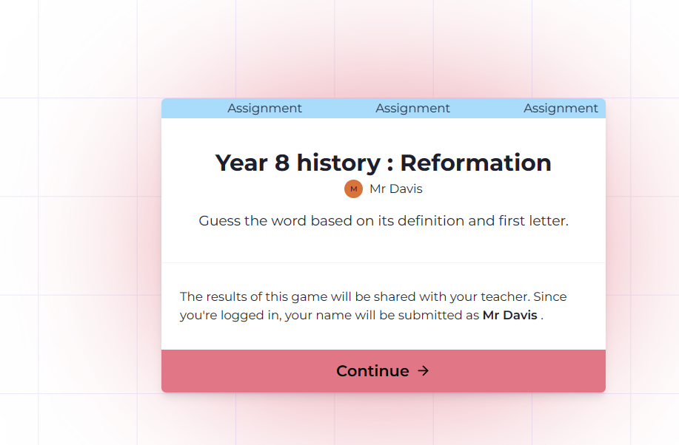 This will then appear

Click on the continue box and this will start the knoword quiz. The results will be recorded each time your child takes the quiz, they can take the quiz as many times as they want and every time they do scores will be recorded, this gives the teachers an opportunity to have an understanding of the progress that pupils are making with learning the key subject vocabulary.

There are no problems if your child does not want to take part in the knoword quizzes and there are no sanctions if your child does not take part but Croft Dojos will be awarded for pupils who do attempt the quizzes. Pupils will also be taking part in the quizzes at school so they should know how to use the systems.

If you need more information about this initiative please don’t hesitate to get in touch by the usual methods such as Class Dojo, email or by contacting the school office.

Yours faithfully

Lee Davis
Head of School

